Marketing and Advertising Kit
and Rate Card 2017

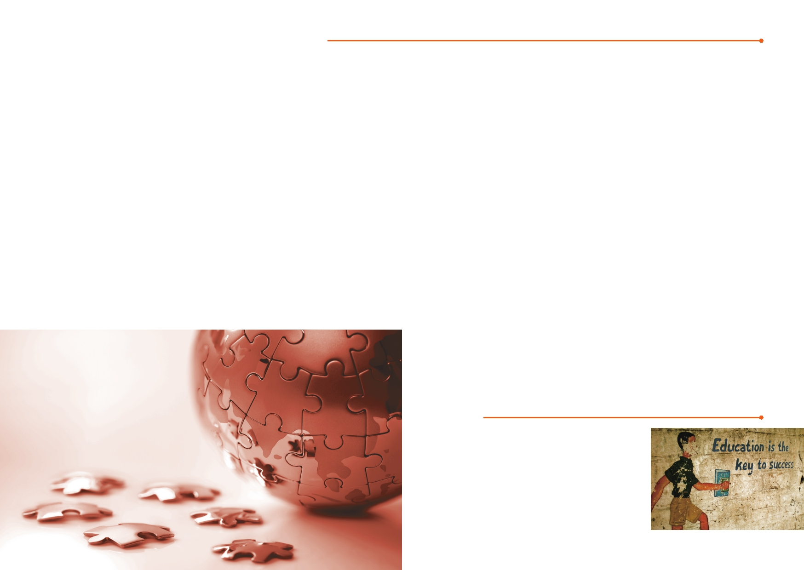
INTRODUCTION

Social Dialogue Magazine

Social Dialogue (SD) Magazine is published by International
Association of Schools of Social Work (IASSW) on a quarterly basis for both online and print version to distribute worldwide. It has served and developed as a primary platform for IASSW members, programs, faculty and students to communicate with
each other on the global social work education and development across physical distance.

Since the inception of April 2011, SD has published 15 issues of
global social topics, including Social Work Education, Human Trafficking, Asylum Seekers, HIV & AIDS, Environment and Sustainable Development, Disaster Response & Management,
Community-based Social Economy, Gender, Disability. The SD Magazine has successfully established its reputation as a
professional magazine among social work educators, students,
practitioners, university administration and governments, for free access and quality discussion. With four times each year, the SD Magazine has built up a reliable network and a stable
source of contributors and readers from all over the world, hitting over 200,000 clicks online each issue.

International Association of Schools
of Social Work
International Association of Schools of Social Work (IASSW)
is the worldwide association of schools of social work, other
tertiary level social work education programmes and social work educators. The IASSW promotes the development of
social work education through the world, develops standards to
enhance of quality of social work education, encourages
international exchanges, provides forums for sharing social
work research and scholarship, and promotes human rights and social development through policy and advocacy activities.

IASSW holds consultative status with the United Nations and
participates as an NGO in UN activities in Geneva, Vienna an
d New York. It represents social work education at the internati
onal level. IASSW was founded in 1928 at the First
International Conference of Social Work held in Paris. It
started with 51 schools, mostly in Europe, and was known as the International Committee. Now IASSW has grown into an
organisation of over 300 membership universities in 87 countries worldwide.

SD Magazine offers the readers a
comprehensive portfolio of channels from print-out magazines to online portals, mobile and tablet editions, from social media (Facebook) to eDM newsletters. This all adds up to the exciting options of our readers (students, educators and practitioners) to meet the different needs of our advertisers.

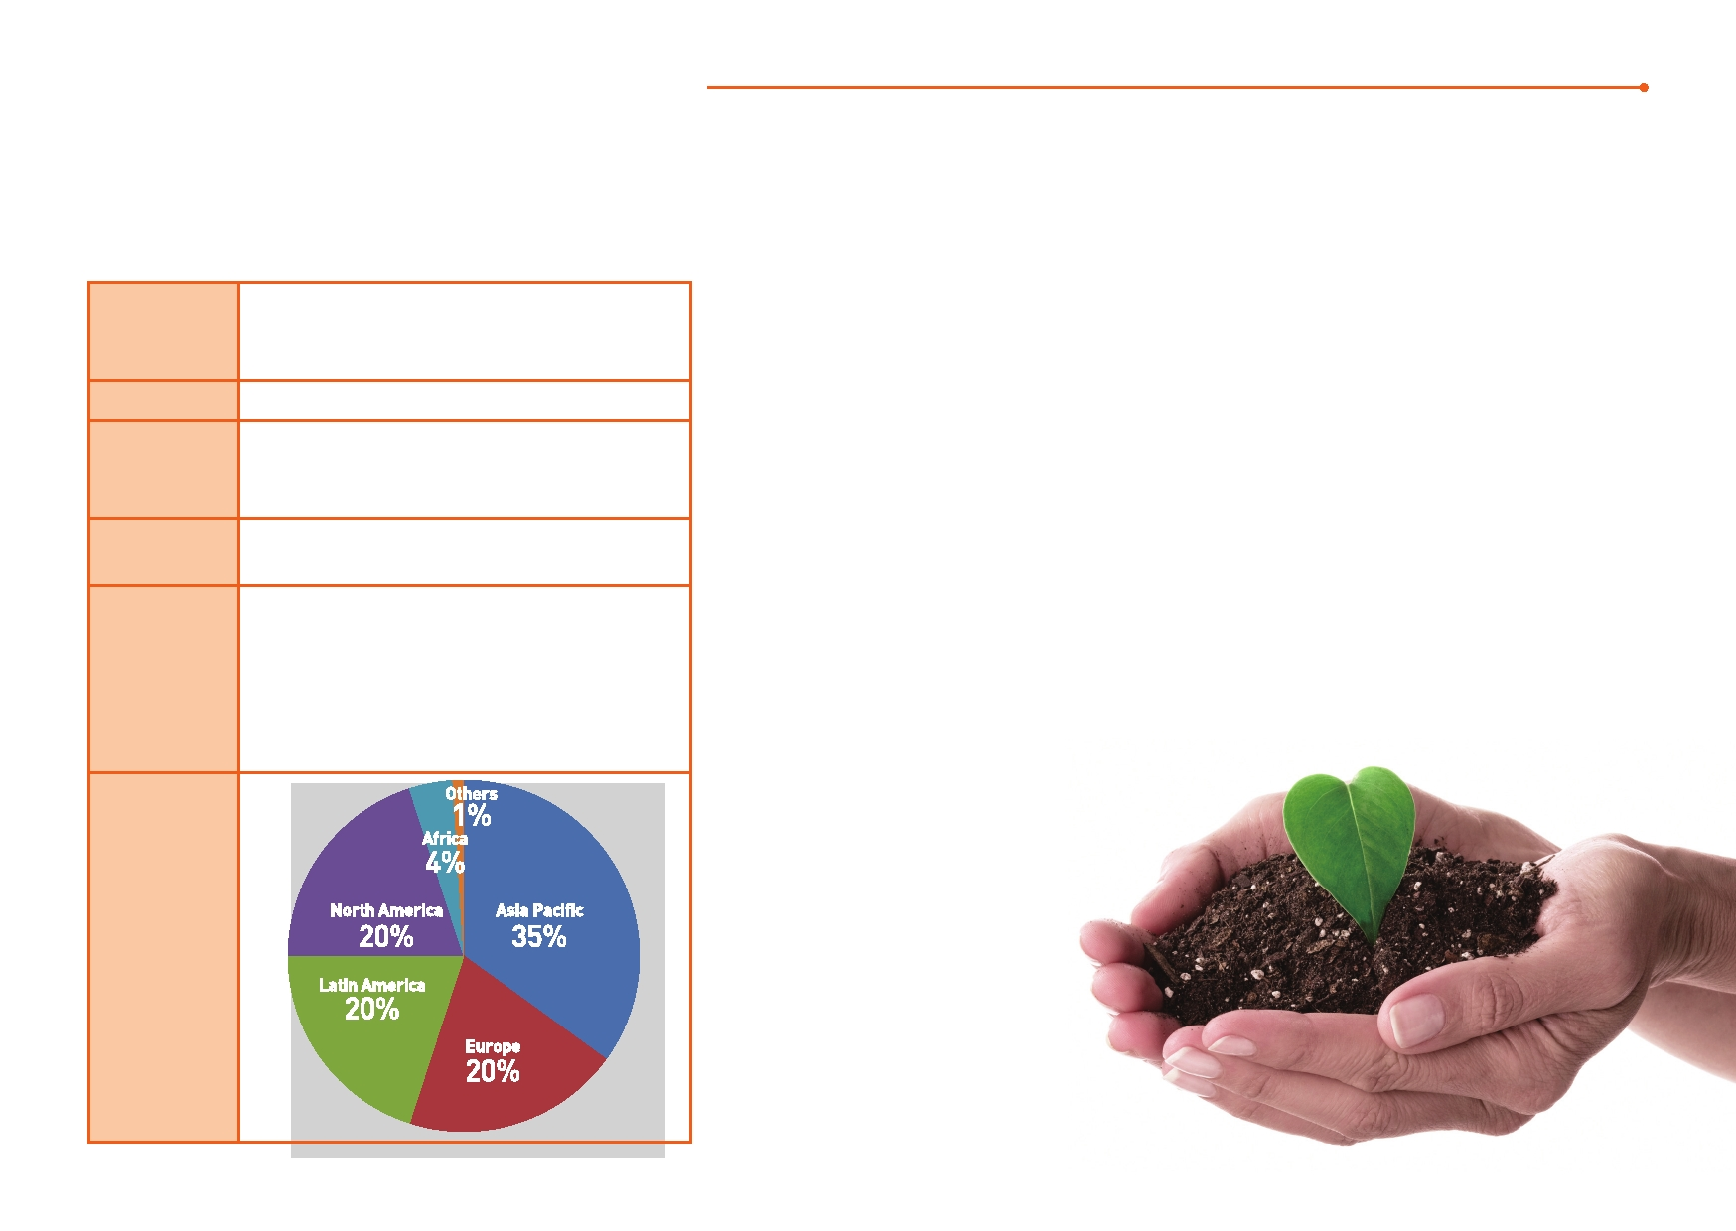
READERSHIP

Our Readership - Key Statistics Collaboration with SD Magazine to
Make an Impact

Circulation

5,000 per issue
(To be distributed through more than 400 membership universities to reach its libraries and departments)
In 2015, SD Magazine continues its focus on global social
work education and social development with upcoming four
issues on conflict resolution, social work without borders,

Online Clicks 200,000 per issue international social work education and social research. Our
contributors from social work practitioners and teaching

Age

Gender

Occupation

Region
• 29 years old or below
• 30 to 49 years old
• 50 years old or above
• Male
• Female
• University Faculty;
• Students;
• NGOs Leaders;
• Practitioners; • Governments • Etc.
faculty will reveal behind the heated issues and triggered
substantial discussions on social work education. We are
reaching more students, highly educated professionals and
government officials to read us and engage the social issues
with SD. With ever-expanding network of distribution, we offer you a great exposure to the global readership and help
enhance the branding image and your corporate social responsibility.

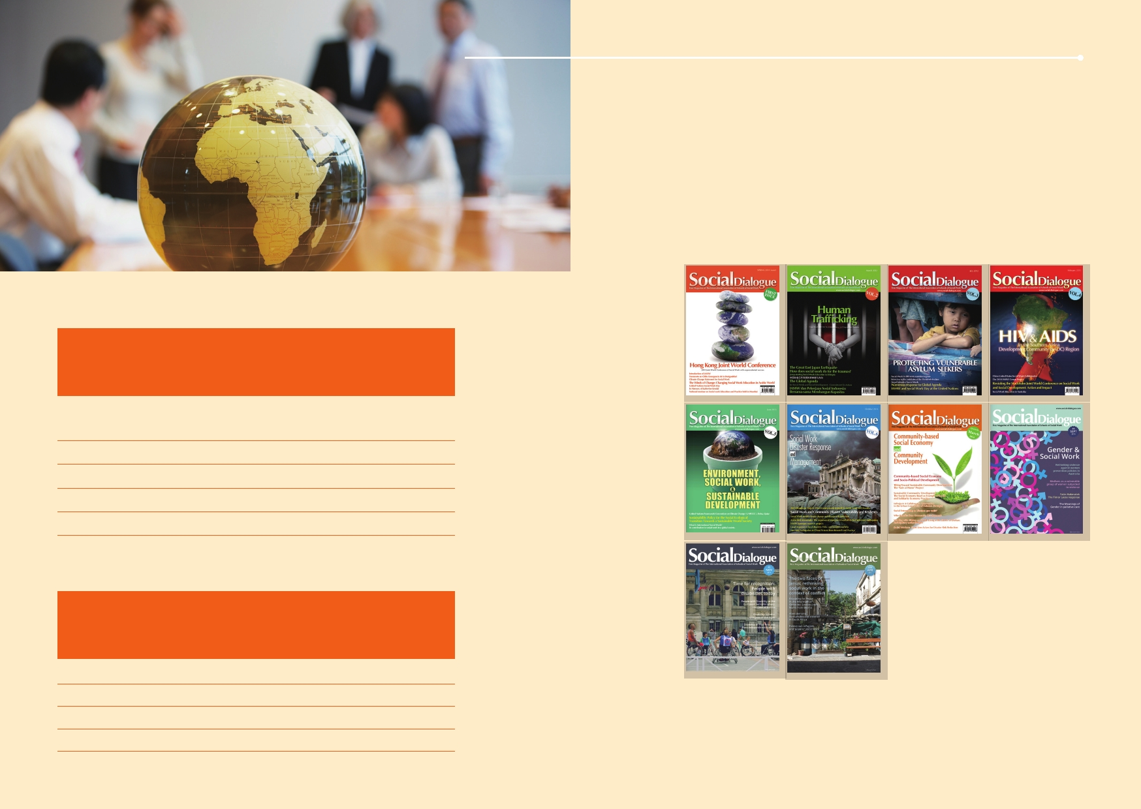
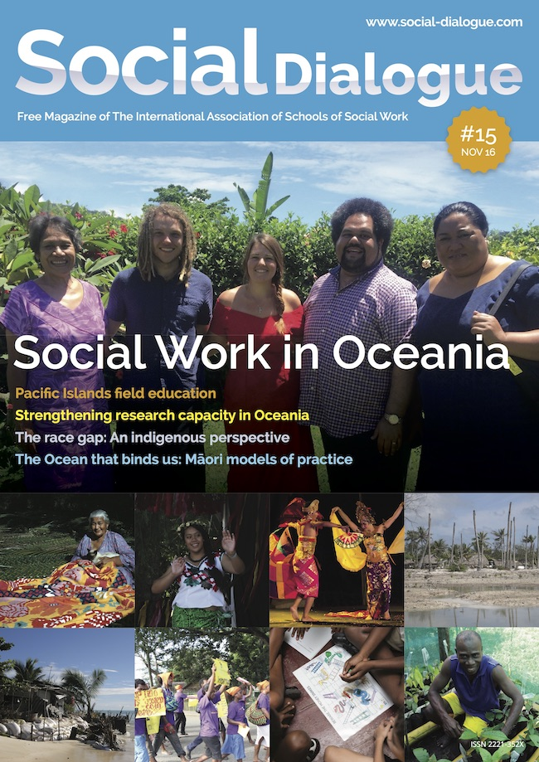ADVERTISING

Material requirements
• High resolution PDF preferred with minimum 300dpi print-
optimized with fonts, logos, graphics and images embedded

Display Advertising

Full Page
(Special Placement)
Full Page
Half Page Horizontal
Half Page (Low income countries)
Quarter Page

Specifications
Size

Size
Full Page
Half Page Horizontal
Half Page Vertical
Quarter Page

1 quarter

US$1,000

US$850
US$500 US$250 US$300

Inches 8 x 12
8x6
4 x 12 4x6

Full year

US$ 3,000

US$2,550
US$15,000
US$1,000

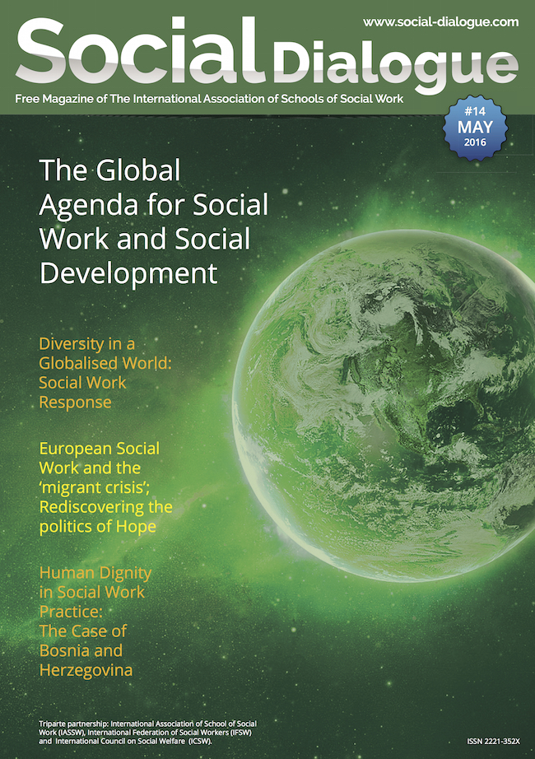

MM

210 x 297
210 x 149 105 x 297 105 x 149

Contact

hello@iassw-aiets.org

