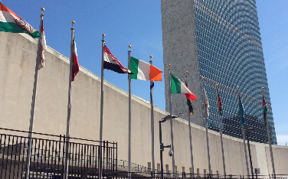
Notes from the field…

Why the UN Matters to Social Work: IASSW Team Presentation
Why, indeed, should the United Nations matter to social work and social work education? This was the topic of a panel presentation by the IASSW UN Team of Representatives at the annual conference of the Council on Social Work Education in the United States in October. Panelists discussed the UN as a forum where critical global social issues of high relevance to the profession are discussed; as a repository of data, research and other resources to enhance social work education; and as a target for advocacy to strengthen UN policies for human rights and human well-being.
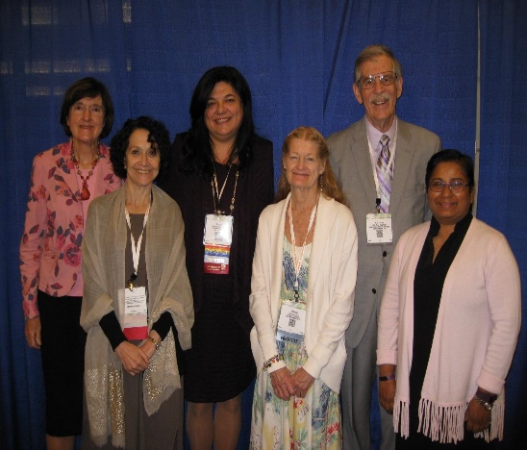
The United Nations 2030 Agenda for Sustainable Development and 17 sustainable development goals (SDGs) (United Nations, 2015) include issues high on social work’s agenda including migration, poverty, human rights, the environment and sustainability, and discrimination and xenophobia. The issues are closely linked to those outlined in the IASSW, ICSW, IFSW Global Agenda for Social Work and Social Development. In addition to areas of common purpose, the IASSW representatives emphasized the need for social work advocacy and input. The challenge of the UN 2030 Agenda (2015) is to “leave no one behind” in the quest for sustainable development and poverty eradication. Governments alone are poorly equipped to even identify those living in extreme poverty; NGOs and social workers who work directly with vulnerable populations are best able to identify and mobilize such groups. As your representatives, we can also bring ethical considerations into the UN debates, using freedoms not accorded to government representatives. As the head of CoNGO (the coalition for NGOs at the UN) said, “competent and responsible NGO/CSO input to intergovernmental debate and decision- making is a major factor in enhancing competent and responsible government output” (2017). Presenters Rebecca Davis, Shirley Gatenio Gabel, Lynne Healy, Terry Hokenstad, and Rebecca Thomas drew on their own advocacy work with the UN system and experience as educators familiar with UN resources to illustrate commonalities and needs for advocacy and each suggested several UN publications as examples of the rich resources available on the UN website to enhance teaching and research.
IASSW Team Members: left to right Lynne Healy, Martha Bragin, Shirley Gatenio Gabel, Rebecca Davis, Terry Hokenstad, Rebecca Thomas.
YOUNG PROFESSIONALS

On November 14, the Young Professionals working with NGO’s at the UN held a meeting focusing on gender equality and women’s issues. They showed the documentary, Half A Sky, which is by the journalist Nicholas Kristof. In the film, he highlights the work of women in various countries who are helping young women and girls dealing with cultural norms and practices which oppress and marginalize these populations. The film is meant to expose these realities in the hopes that global outrage will help to change these norms. In Sierra Leone, the film follows a woman who runs Rainbow House which counsels and helps victims of rape. Mr. Kristof explains that after long periods of war, rape remains as a culturally acceptable leftover of prolonged conflict. The documentary follows the story of a young fourteen-year-old girl who has been raped by her “uncle” and local pastor. Courageously, she reports this rape to the police and the pastor is arrested. Sadly, as the story evolves, the pastor is exonerated and the young girl is rejected by her family for disrespecting them and their larger community. She can no longer go to school and has been left homeless. The Director of Rainbow House states that they have reported over 10,000 rapes to the police in Freetown and only one has ever been prosecuted. These young women in war torn countries are not protected emotionally, legally, or humanitarianly against rape and its aftermath and other gender based violence within their families and communities.

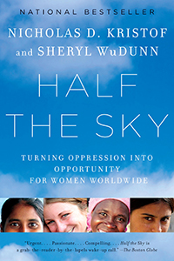
Mr. Kristof then follows the work of a former sex slave who, after escaping captivity, began a foundation working with young women who have been victims of sex trafficking in Cambodia. In the documentary, this woman recounts how she was lured from her village in the hopes of reuniting with her parents, only to become a sex slave who was then sold into a brothel when she was only twelve years old. She was repeatedly beaten and raped by as many as thirty men a day for a decade. She now rescues young girls from brothels with the help of the Cambodian task force on sex trafficking. In the film, we meet girls as young as three years old who were working in brothels. The young women who have been rescued are empowered by the love and support they are given through this organization. Sadly, many of these girls who were kidnapped and imprisoned are rejected by their families and communities upon release from their captors. I highly recommend this film. I was particularly impressed with the energy and commitment of the Young Professional group which hosted the documentary and the discussion which followed.

NEW YORK CITY AND GOAL 8
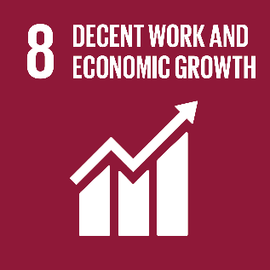
Decent work for all was the theme of a side event at the UN was hosted by The City of New York Mayor’s Office for International Affairs. Entitled “Creating the Conditions for decent work for all: Localizing Sustainable Development SDG Goal 8”, it focused on how the SDGs were being adopted by New York City through its Global Vision/Urban Action Initiative. This is the first meeting I have been to at the UN which focused directly on how the SDGs are being implemented on the ground, especially in a large, wealthy metropolitan city such as New York. This is one of Mayor DeBlasio’s signature initiatives. During the panel introductions, the Belgian Ambassador spoke of his commitment to working towards decent work globally because of the successes they have had in Belgium and how decent work is at the core of his country’s social policies. The Ambassador of Argentina talked about how her country was working vigorously towards the eradication of child labor as well as forced labor domestically and internationally. She informed the meeting that there is an international conference being held this week in Buenos Aires about this subject. The International Labor Organization representative discussed the work his organization is doing towards equal pay and protections for workers globally.
The Consumer Affairs Commissioner for New York City spoke of working towards enhancing the lives of New Yorkers and providing tools for empowerment for the marginalized in the city. Her office of Labor, Policy and Standards is filling the gap in protections left by the state and federal government. This includes helping workers to realize their rights and working with other progressive cities and civil society in order to understand best practices and develop safety systems and work protections. Among them are a paid sick leave law passed in 2015, legislation providing paid leave for people who are victims of domestic abuse, and legislation dealing with fair hours and fair schedules, which will be going into effect soon. It is these sorts of initiatives being implemented by local governments that show the progress of SDG 8 in New York City as well as international initiatives being promoted by Belgium and Argentina.

GLOBAL COMPACT ON MIGRATION
A Global Compact on Migration appears likely in the coming year. During the November Committee on Migration meeting, Ambassador Lauber from Switzerland spoke about how he is very optimistic about the prospects for this Global Compact. He looks forward to the meeting being held early next year in Puerto Vallarta to discuss issues furthering the New York Resolution about Migration of 2016. This meeting will not be about negotiation but about information gathering. The Ambassador is excited about the momentum regarding this subject and hopes that all the resolutions will be adopted by the summer so as not to lose this current enthusiasm. He expressed how important the role of civil society is to information gathering and advice on initiatives. The “Ten Acts for the Global Compact” document produced through the Executive Committee of the NGO group, which details ten aspects which the committee hopes will be considered in Mexico, was an excellent paper with very productive recommendations. He hopes that civil society will continue to speak as a unified and powerful force in these discussions. The Executive Committee is still working on the Ten Acts for the Global Compact document and are presently seeking recommendations from each subcommittee- Climate Induced migration, xenophobia and child refugees.
The UN acknowledges that one of the root causes of global migration is Climate Change. The Ambassador is pessimistic about chances that member states will designate these displaced populations into a new category of migrants. There is a sense that there is not an appetite among member states to do this because of the legal issues involved. Giving climate migrants refugee status would require countries to spend a great deal of funds and resources for these new immigrants, which many countries are not willing to do. He thinks civil society should not push for this change in status but rather advocate for small, specific measures to protect these populations. He also stated that making something legally binding does not necessarily make a resolution more powerful. He used the SDGs as an example of a very powerful resolution but one that is not legally binding. The head of the subcommittee for the Global Compact stated that the Ten Acts document needs to be signed by 1000 NGOs, creating a powerful statement, before being presented in Puerto Vallarta.
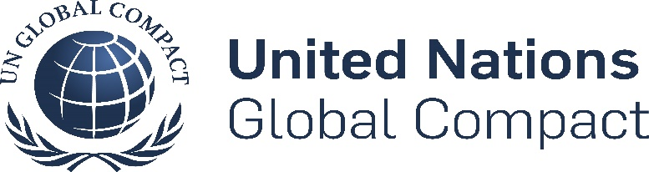
The NGO subcommittee on Climate Induced Migration will be holding a side event on Climate Change and Rural Women to be co-sponsored by the government of Bangladesh during the Commission on the Status of Women in March at the UN.
This subcommittee holds monthly meetings called coffee and compacts where we discuss facts, evidence and timelines for climate change and its impact on human life. This is a subject that lacks concrete data and a wealth of knowledge, so we are each trying to educate each other in these informal meetings. It is an enthusiastic group which includes Rebecca Thomas, Justice Konowe and Shrevie Shepherd as IASSW representatives.

WORKING GROUP ON GIRLS
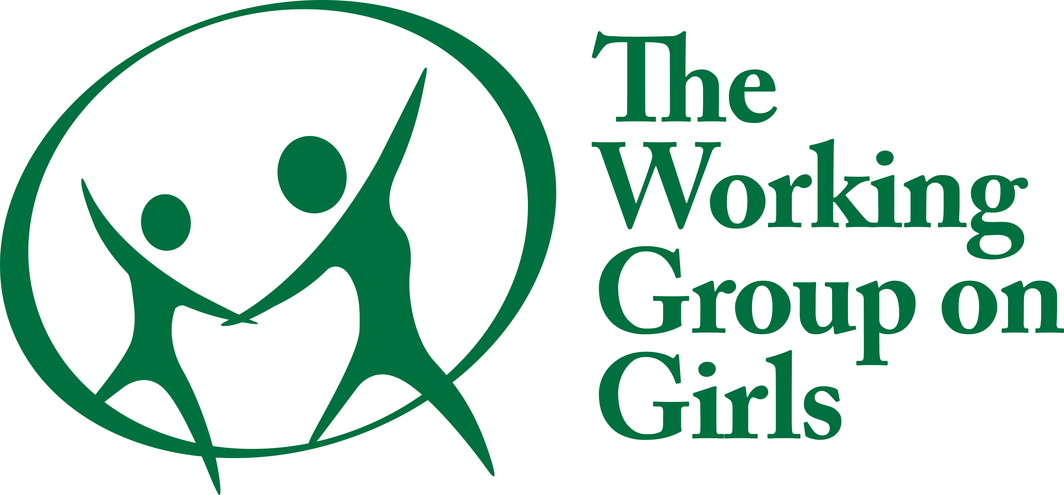
The Working Group on Girls, a lively and enthusiastic group of NGO representatives, recently highlighted girls’ issues in Africa as part of Africa week at the UN. The keynote speaker at the October meeting was Dr. Rima Salah, the ex- deputy head of UNICEF. She talked about her experiences in the field working with and observing the realities of life for girls. She spoke mostly about Africa and the issues for girls in patriarchal societies such as high rates of HIV infection, rape, trafficking, and lack of services such as water, sanitation, healthcare and education. Girls usually have the least voice throughout the world. Yet, there are many positive initiatives. Among these: a project in Jordan where UNICEF partnered with a university to produce a pamphlet explaining that female genital mutilation was not part of the Koran. In Senegal, UNICEF worked with villages to get whole villages to sign off on never performing this ritual again on their girls. In Kenya, UNICEF helped fund a mobile unit which identified and trained rural teachers so that hard to reach girls had access to education. Interestingly, Dr. Salah visited the rebel camps in Uganda which have kidnapped thousands of boys and girls in order for them to understand the rights of these girls. Lastly, she shared concern that girls who have been trafficked have no migrant rights in the countries to which they are brought, which is something that must be changed. This may be an issue for further IASSW advocacy.

AFRICA WEEK AT THE UN
The High-level event, Addressing Climate Change-Migration Nexus and its Implications for Peace and Security in Africa” was held October 19 in the ECOSOC chamber. It was a very formal meeting which was chaired by the UN Ambassador from Equatorial Guinea. It appears to be one of the first high level meetings which focuses on climate change/migration/security in Africa. The speakers provided a broad perspective of the problem from varying points of view such as financial, migration, environmental, peace, agriculture, human rights and development. Interestingly, every speaker noted that climate change, refugees, conflict and terrorism are all interconnected, most likely to underscore the need for action on climate change. Important points included: the need for large investment in Africa, the need for implementing new technologies, and the need for inter-agency, inter-governmental coordination when working towards sustainable development. It was shocking to learn that 90% of Lake Chad which is the main water source for 21 million people, has dried up. These millions of people can no longer live here and are forced to resettle. The talks were all positive and gave recommendations for future work as well as preventative measures which should be explored.

UN Working to Improve Situations Around the World!
The Third Committee is hard at work! On 16 November 2017, the Third Committee of the General Assembly, which focuses on social, humanitarian and cultural affairs, met for its 47th meeting of the 72nd session. The purpose for their meeting was to deliberate a number of draft resolutions pertaining to human, civil, and political rights. The first order of business of the morning was to discuss a draft resolution regarding the human rights situation in Myanmar (Document: A/C.3/72/L.48). This draft resolution was proposed by the Organization of Islamic Cooperation and co-sponsored by a number of member states. Following the presentation of general comments related to the resolution by many member states, a vote was conducted by the committee. The draft resolution received 135 votes in favor, 10 against, and 26 abstaining. The resolution was adopted with the majority support of the third committee.
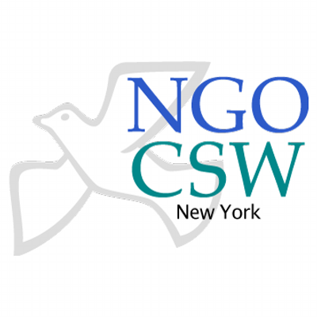
Additionally, member states unanimously agreed to adopt resolutions pertaining to “Improvement of the Situation of Women and Girls in Rural Areas” (Document: A/C.3/72/L.22/Rev.1), and “Enlargement of the Executive Committee of the Program of the United Nations High Commissioner for Refugees“ (Document: A/C.3/72/L.60). Each of these documents were accepted without a recorded vote.
Finally, the Russian Federation introduced a draft resolution titled “Combating Glorification of Nazism, Neo-Nazism and Other Practices that Contribute to Fueling Contemporary Forms of Racism, Racial Discrimination, Xenophobia and Related Intolerance” (Document: A/C.3/72/L.56). Following the Russian Federation’s supporting statement, the United States requested a number of amendments to the document. A vote was held to accept the amendments which failed to receive the majority vote, therefore, the amendments were rejected. In an effort to complete business before the end of the morning session, the Chair of the third committee meeting purposed an immediate vote on adopting the draft resolution without amendments which passed with 125 votes in favor, 2 against, and 51 abstaining. It was an interesting morning for those working on human rights and humanitarian efforts! To watch this meeting and others like it, visit the UN web TV link below!
http://webtv.un.org/search/third-committee-47th-meeting-72nd-session/5649013834001/?term=third committee 47th&lan=english&sort=date

NGO Committee on the Status of Women

The assembly hall of the International Salvation Army was buzzing with attendees eager to hear from several impressive women. The NGO Committee on the Status of Women (CSW) held a panel discussion to provide insight for inclusive and sustainable practices in urban planning and development. “Sustainable and Safe Cities; Focusing on the New Urban Agenda” was the title of the event and panelists included Patricia Cortes from UN Women, Dr. Samantha MacBride from the NYC Department of Sanitation, and Janice Peterson, chair of the board, Huairou Commission in New York. Key themes from the discussion included the importance of including women in urban development, the use of curb side organic composting systems as a point of commonality, the concept of including caring characteristics in policy development, and the importance of maintaining a global focus but also taking action at a local level.
The event highlighted the importance of including experts in all areas from communities in order to organize and advocate for implementation of the SDGs. Dr. MacBride emphasized that sanitation and waste removal programs play a role in the work of civil society. Through the New York City’s waste prevention and curbside organics programs, local communities are learning how to produce food, minimize waste, and are educating future generations about more sustainable sanitation practices. The need for food and waste removal are issues on which people from all different walks of life can come together. All three panelists encouraged advocates to organize their communities around unifying issues and use the strength gained in numbers to create change on a global level. The topic and speakers were inspiring to all who attended!
For more information on the work being done by the NGO-CSW please visit their website at https://www.ngocsw.org/

What the IASSW UN Team is Up to?

IASSW UN Representatives are staying busy this fall with their work on various NGO committees. Representative Dr. Lynne Healy, and interns Justice Konowe and Shrevie Shepherd are actively working with the Grassroots Taskforce, a subcommittee of the Committee on Social Development. Their work includes analysis of the data received from its 2017 survey, developing brief statements summarizing the data, and planning a side event to be held during the Commission on Social Development in early February. IASSW is also applying for a joint side event with the ICSW (International Council on Social Welfare) for the Social Development Commission. This program will emphasize social protection. In addition, interns Justice and Shrevie, as well as Representative Dr. Rebecca Thomas are engaging in work with the Committee on Migration, focusing on climate induced displacement. Their work on this committee includes planning a side event to be held during the Commission on the Status of Women (CSW) in March and will emphasize the impact of climate change on rural women. Representative Dr. Shirley Gatenio Gabel is in the beginning stages of planning another parallel event to be sponsored by IASSW at the CSW. Finally, the interns are also collaborating with social work students from Fordham University, Monmouth University and Hunter College to plan the Social Work day at the UN’s student event which will be held on March 25th at the Fordham University’s Lincoln Center Campus. Stay tuned for more information on upcoming events.
To read more about the upcoming sessions of these UN Commissions, visit http://www.unwomen.org/en/csw/csw62-2018 for the Commission on the Status of Women, and https://www.un.org/development/desa/dspd/united-nations-commission-for-social-development-csocd-social-policy-and-development-division/csocd56.html for the Commission on Social Development

Respectfully,
Justice Konowe
MSW Candidate 2018
IASSW Representative to the United Nations
UCONN School of Social Work
Email: justice.burch@uconn.edu
Shrevie Shepherd
MSW Candidate 2018
IASSW Representative to the United Nations
UCONN School of Social Work
Email: katherine.shepherd@uconn.edu

ALERT: SOCIAL WORK DAY AT THE UN WILL BE HELD ON MONDAY, MARCH 26, 2018

