International Association of Schools of Social Work
International Project Grant
Final Report
August 4, 2017

Title: MSW Program Development in Ecuador, Mexico, and the United States

Coordinating Institution: Universidad Estatal de Milagro, Ecuador (UNEMI)
Participating Institution: Universidad Autónoma de Aguascalientes, Mexico (UAA)
And Dominican University, USA (Mentoring Institution)

Project Participants

- Ecuador (UNEMI – Universidad Estatal de Milagro): Dr. Fabricio Guevara Viejo (Coordinator), Dr. Zoila Barreno Salina, and Mrs. Monica Zea
- Mexico (UAA – Universidad Autónoma de Aguascalientes): Dr. María (Maru) Perea Velázquez, Prof. Zapopan Tejeda Caldera, and Prof. Bernardo Guerrero Góngora
- USA (Dominican University): Dr. Joyce Shim (Mentoring Faculty) and Dr. Leticia Villarreal Sosa

Background and Summary

We submitted our application for the IASSW International Project Grant so our team from three countries – Ecuador, Mexico, and the USA - can begin the process of developing the only MSW program in Ecuador. Hosted by UNEMI in Ecuador and supported by the IASSW Global Project Grant, faculty from three schools of social work gathered for the two-day conference (where faculty, staff, and students from 12 different social work schools that grant BSW in Ecuador also joined) as the next step to achieve the goal. The IASSW grant helped UNEMI prepare this event and provide all resources needed for our joined activities.

Timeline and Tasks Completed
After Interim Report (Since January 2017)

Timeline | Task | Accomplished as Planned?  (Yes / No)
May 2016 | UNEMI faculty visits Dominican and formalizes the university-wide partnership. | Yes
July 2016 | Dominican faculty visits UNEMI to initiate preparation for the workshop in 2017 and setting a detailed agenda for both universities. Meeting with UNEMI’s faculty and students. Attending UNEMI’s conference on education and development. | Yes
September 2016 - October 2016 | Participants complete and share their detailed agenda. Communications via Skype. | Yes
November 2016 | Participants prepare the workshop in Ecuador according to the agreed agenda. Participants also plan lectures to share at UNEMI. | Yes
December 2016 | Trip plans are complete. Workshop logistics are ready. Invitations to appropriate faculty, students, staff, community leaders, and partner schools and agencies in Ecuador are complete. | Yes
January 2017 (Pictures are attached at the end of the report) | All participants gather at UNEMI, Ecuador. Guest lectures are shared at various classes and one-week workshop is held. The PDF Program is attached separately in the email. | Yes
January 2017 – Marcy 2017 | Participants at each institution go back home and prepare an interim evaluation report and the coordinator compiles the reports and submits to IASSW. Participants follow up and share detailed action plans for future. | Yes
April 2017  (Pictures are attached at the end of the report) | Participants from UNEMI and UAA revisit Dominican (NOTE: supported by participating universities) to present at Dominican’s annual Global Symposium 2017 to discuss our on-going collaboration and development of the MSW program in Ecuador. The PDF program is attached separately in the email (please see PG. 19). For more info, please go to http://www.dom.edu/ursci/expo | Yes
Summer 2017 | Participants complete the documents necessary for launching of the MSW program at UNEMI, Ecuador. | Ongoing (Expected to be finished in August)

We are excited and proud to report that according to the timetable above, all tasks have been successfully implemented and executed. The team gives many thanks to the generous support of the IASSW.

Discussion of Activities and Conclusions

(1) Lectures at the conference and visiting classes: Faculty from the USA and Mexico joined students and faculty at UNEMI and those from other 12 social work schools that grant BSW to learn more about their experience and expertise on social work in Ecuador and discuss some of the challenges they are facing while getting their education both in classes and internship placements.

(2) Drafting a book: Envisaged research and dissemination of findings: The team built a detailed and strategic plan to write a book together on their experience in social work education in the global setting, multi-country collaborations and exchange programs for social work students and faculty, and also about promoting social work education in developing countries, particularly in Latin America. The table of content is available upon request.

(3) Meeting with community leaders and visiting partner agencies: Participants visited / revisited local NGOs and partner agencies in Ecuador. It was to explore any collaboration opportunities both through research or teaching. Participants successfully identified some of the areas where exchange of expertise and capacity-building efforts can be implemented in the future.

(4) Signing of the Tri-university MOU: In October of 2017, university representatives from Dominican, USA and UNEMI, Ecuador will visit UAA, Mexico to sign the tri-university MOU (NOTE: supported by participating universities). This official acknowledgement of the partnership will benefit all academic and internship activities exchanged and collaborated with the three institutions – not simply for the students but also faculty and staff involved in any international work.

Important Note to the Grant Committee:

We thank the committee for sending us $3,000 instead of $2,500 previously. Given the lack of resources for public universities in Ecuador, the additional fund was extremely helpful for the team to continue the work.

The remaining $1000 can be deposited to the bank account of Dr. Joyce Shim, the mentoring faculty (her account info is separately attached in the email). As you remember, while IASSW attempted numerously to deposit the fund to colleagues in Ecuador, it was never successful (it was sent to Dr. Leticia Villarreal Sosa last time). If you have any questions or concerns regarding this matter, please contact Dr. Joyce Shim directly at jshim@dom.edu.

We thank you for IASSW’s continuous support and guidance in our project.
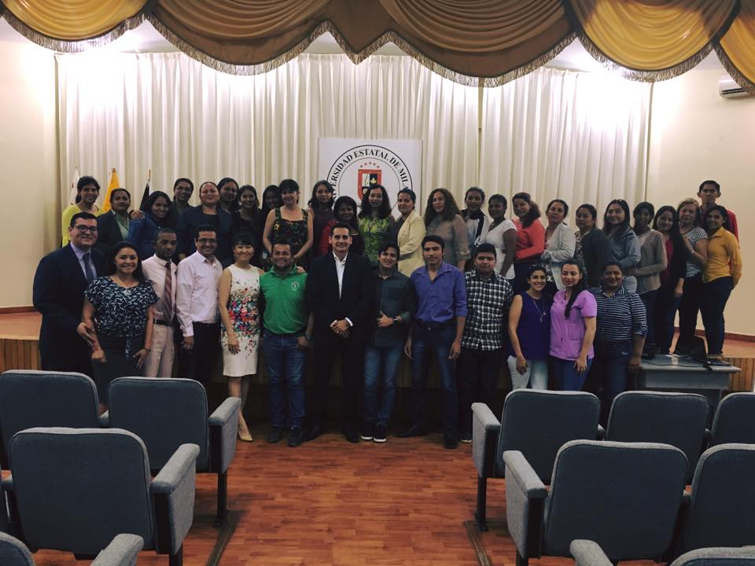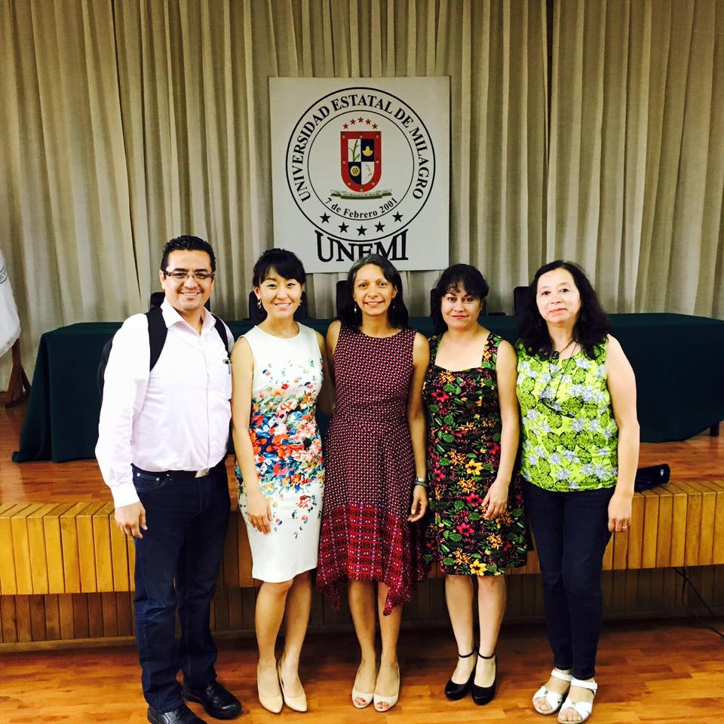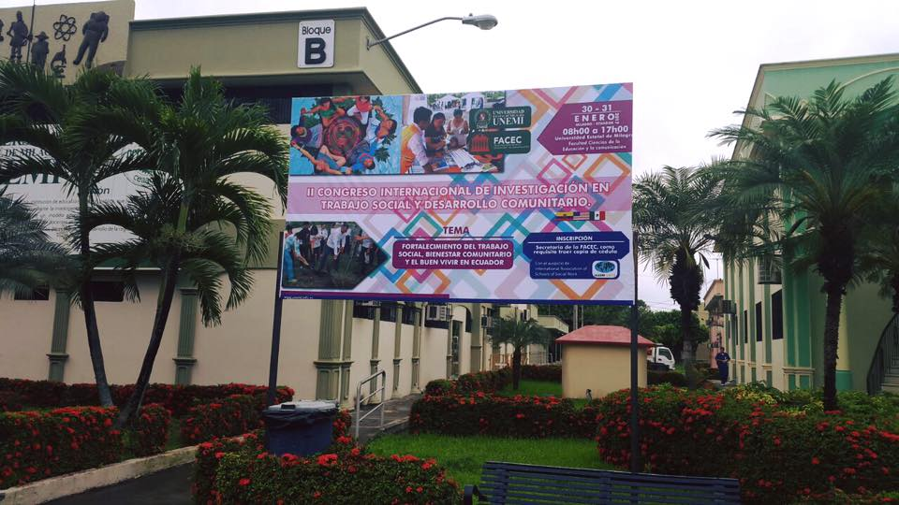
January 2017
A group picture with the faculty from three institutions - Dominican University, USA, Universidad Autonoma de Aguascalientes, Mexico (UAA), and Universidad Estatal de Milagro, Ecuador (UNEMI) - at UNEMI (Universidad Estatal de Milagro, Ecuador) and the University’s students after the conference.
Faculty, staff, and students from 11 social work schools (BSW) in Ecuador gathered and had a chance to network. Worth celebrating!
Faculty from Dominican, USA and UAA, Mexico. Thanks for their wonderful lectures!

The poster at UNEMI on our Conference – El Congreso Internacional de Investigación en Trabajo Social y Desarrollo Comunitario [The International Conference on Social Work Research and Community Development]. Thank you IASSW for its support for our tri-university collaboration!

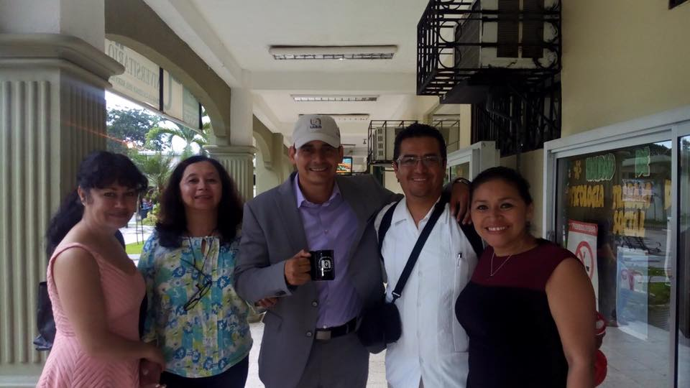

Faculty from UAA (Professors Zapopan, Maru, and Bernardo) posing with UNEMI’s chief of staff Mr. Byron Pierda and Social Work Coordinator Mrs. Monica Zea. We celebrated our newly formed partnership and friendship.
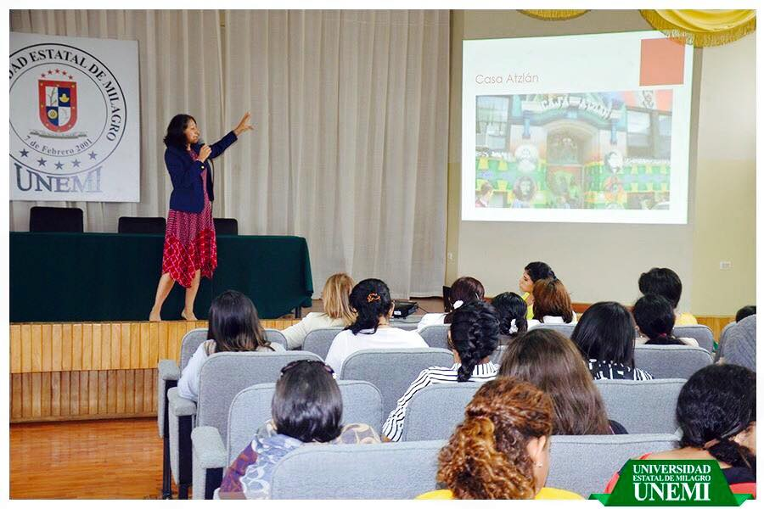
Dr. Leticia from Dominican giving a lecture on Social Work Education in the United States.

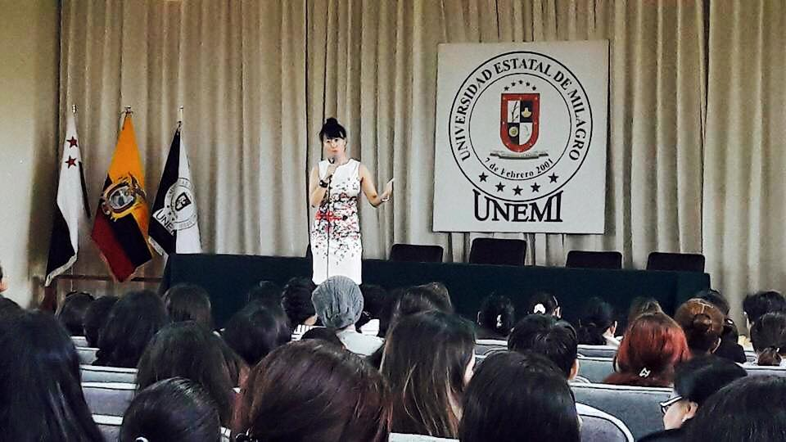

Dr. Joyce from Dominican sharing her experience.

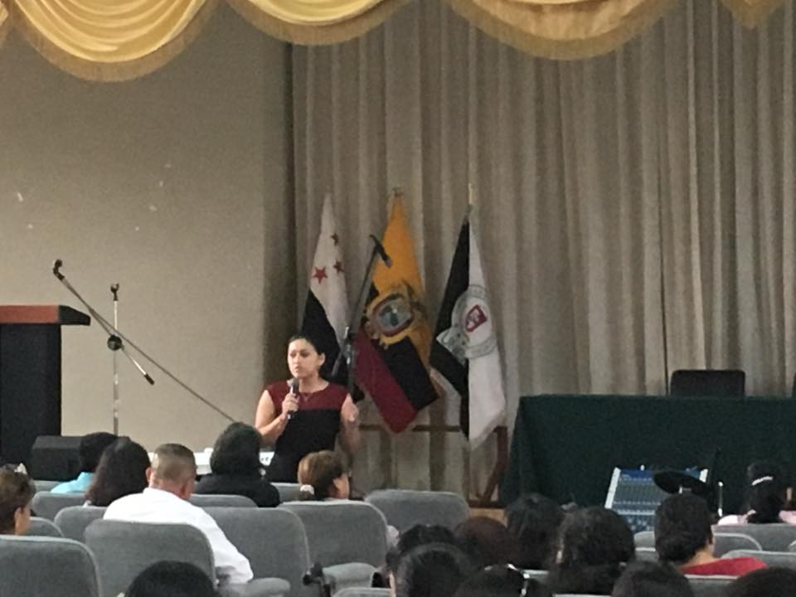

Social Work Coordinator Monica of UNEMI giving a lecture on Health Care and Social Work in Ecuador.

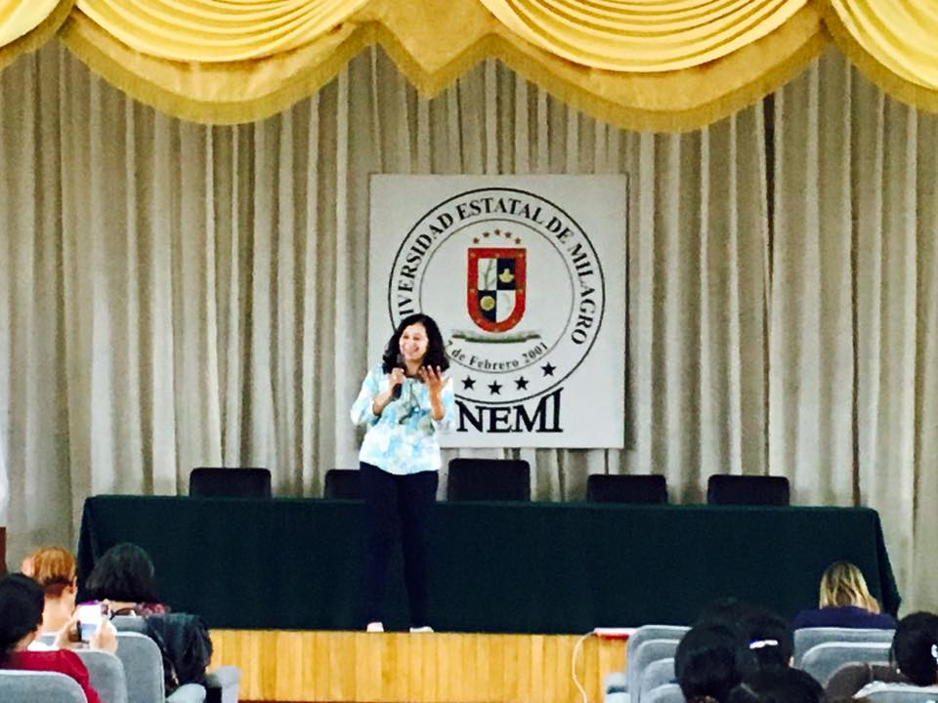

Dr. Maru from UAA sharing her experience as a social work scholar and educator in Mexico.

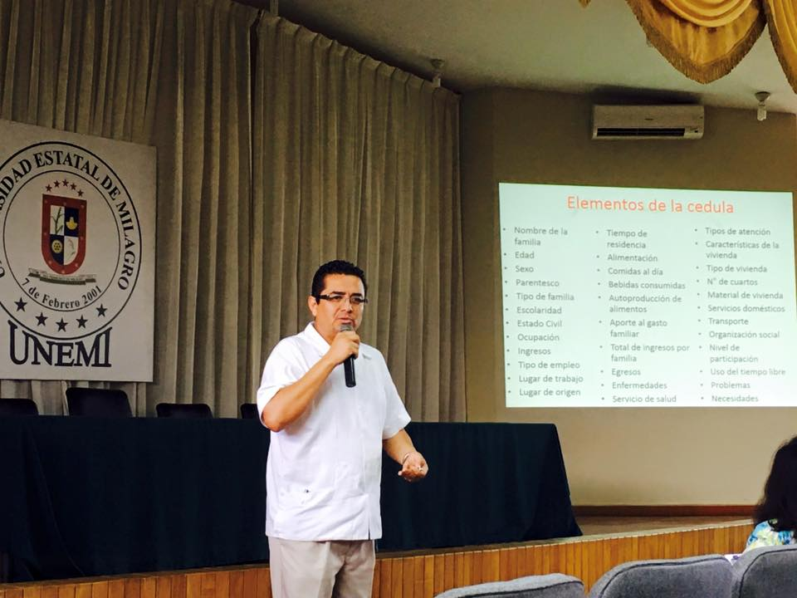

Professor Bernardo from UAA giving a lecture on Social Work Research and Methodology.

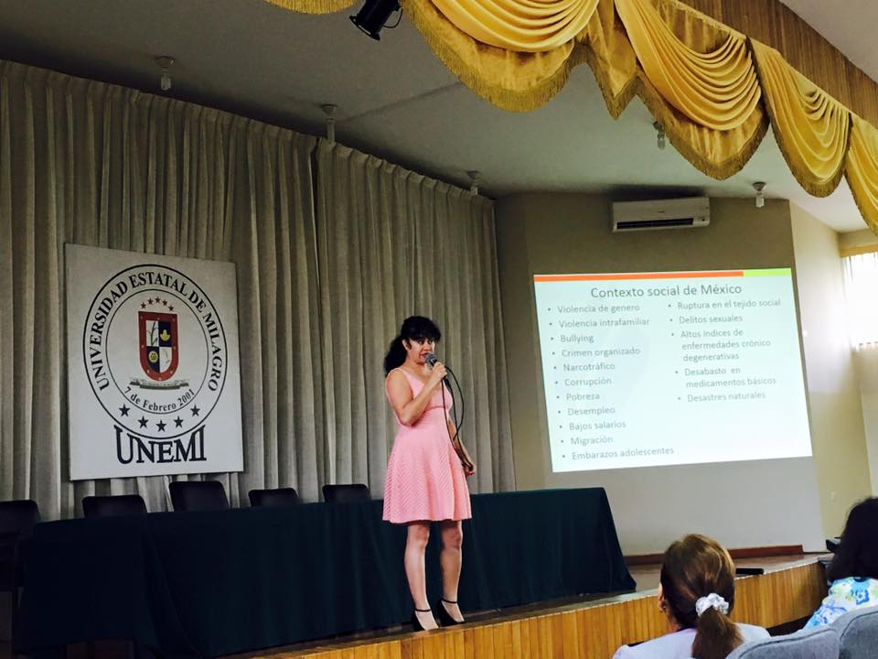
Professor Zapopan covering the theme of Social Work Education in Mexico.

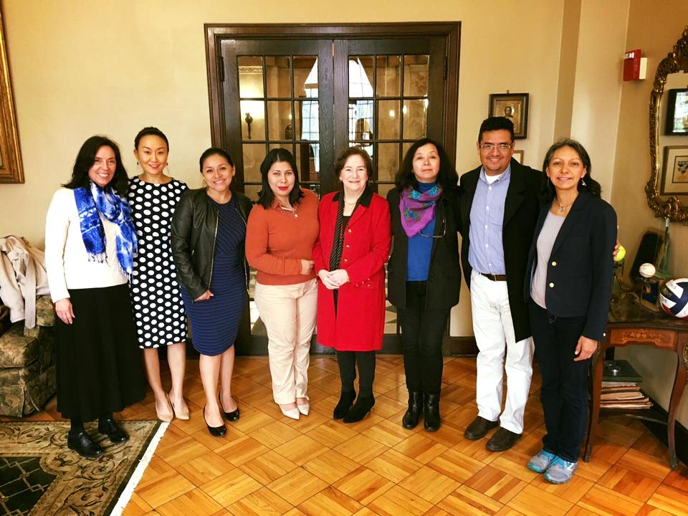

April 2017

Partners from UNEMI and UAA revisited Dominica for the University’s annual Global Symposium 2017, where the team presented the on-going collaboration. The picture is taken with Dominican’s President Dr. Donna Carroll.

The program is attached separately in the email (please see pg. 19). For more info, please go to http://www.dom.edu/ursci/expo

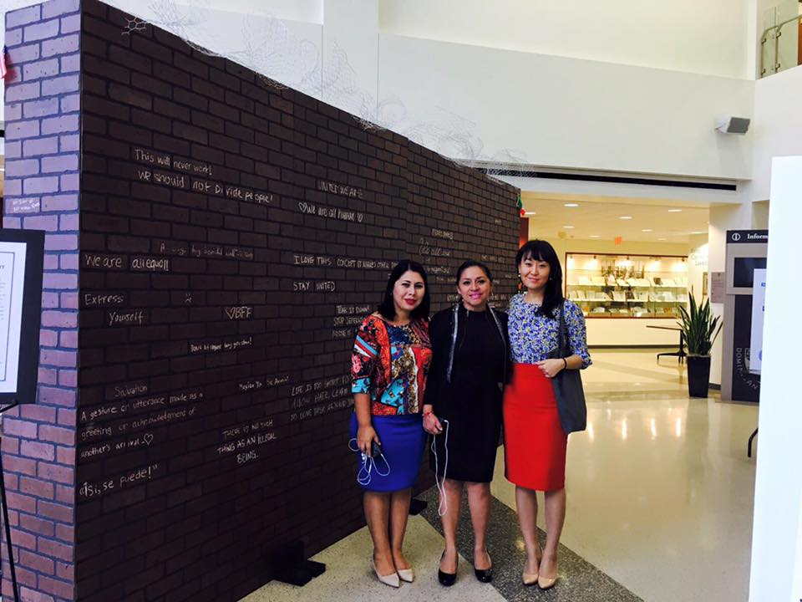
With Dr. Joyce Shim, mentoring faculty, and colleagues of UNEMI - Monice Zea and Diana Macias at Global Symposium 2017 at Dominican University. The program is attached separately in the email (please see pg. 19). For more info, please go to http://www.dom.edu/ursci/expo

Our interim report submitted in December 2017 is attached in the email separately.

