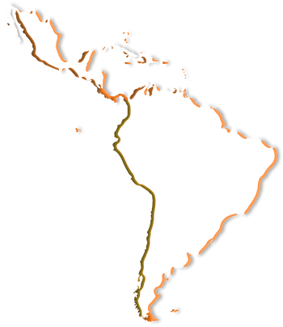
S
Asociación Latinoamericana de Enseñanza
e Investigación en Trabajo Social



Sede Puerto Rico

RePORT
January- JUNE 2018

dr. nilsa burgos ortiz
president ALAEITS

Activities of the Board of Directors

The President and members of the Board were engaged in the following activities:

- Participation in the Mini Conference at University Of Zagreb, Croatia with the topic “Social work education in Latin America”.
- Elaboration and dissemination of the newsletter “Habla ALAEITS”, number 18 (See link http://www.ts.ucr.ac.cr/html/alaeits/binarios/habla-alaeits-2017-00018.pdf).
- Elaboration and dissemination of two statements:1) Solidarity with democracy in Brazil, Nicaragua and the working classes that went out in the streets to defend their rights; 2) Against the assassination of Marielle Franco in Rio De Janeiro, Brazil and in support of the declaration of the Brazilian Association of Education and Research in Social Work. (See link
http://www.ts.ucr.ac.cr/html/alaeits/alaeits-es-pronunciamientos.htm)
- Seven meetings of the Board of Directors have taken place. Among the issues discussed were: follow up on the Working Plan, ALAEITS statements, ALAEITS newsletter and the Latin American Seminar of Schools of Social Work (work on commissions, revision of budget and revision of an agreement).
- Skype meetings related to the planning of the Seminar to be celebrated on September 24-28, 2018 in Bogotá, Colombia. Four were meetings with the Academic Commission and three with all commissions.
- Participation in two panels of the Encounter of the South Region of ALAEITS, University of Santa Fe, Argentine, May 31 and June 1rst. The main topic was
Professional education in social work. As part of the encounter an homage was held for the distinguished professor Margarita Rozas, a well known author in topics such as social policy and research in social work. The President also met with national representatives of Brazil, Paraguay, Uruguay and Argentina to discuss ways to strengthen the association and to offer information about the seminar to be held in Bogota, Colombia.

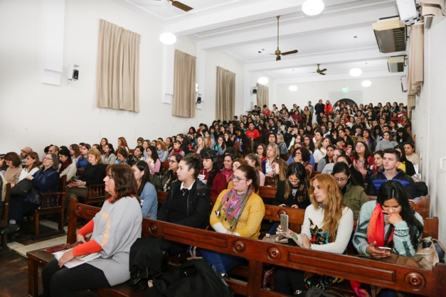

- Spanish proofreading of the translation from English to Spanish of the
document: “Declaración de principios éticos del Trabajo Social”.

