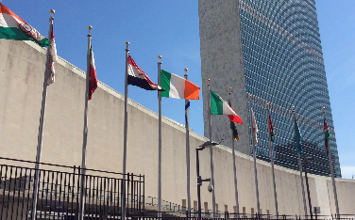
Notes from the field…

WORLD AIDS DAY EVENT: THE RIGHT TO HEALTH

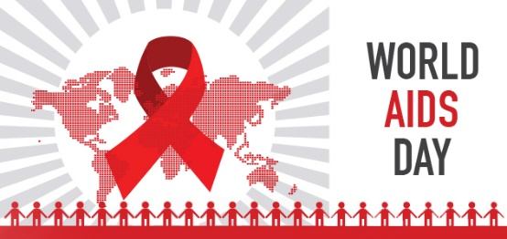
In recognition of World AIDS Day, December 1, the Department of Public Information (DPI) at the UN and UNAIDS jointly hosted a panel discussion entitled, “The Right To Health.” The speakers all approached the HIV/AIDS crisis from different points of view: Human Rights, Global Health, Sustainable Development and a South African Activist perspective. The panelists included Simon Bland, Director of the New York Liaison Office of UNAIDS, Dr. Nata Menabde, Director of the World Health Organization, NY, Christian Courtis, Human rights Officer with the UN High Commission on Human Rights, Ms. “Steve” Letsike, a human rights activist from South Africa and Tenu Avafia, an HIV specialist from the UN Development Program. The Director of the DPI explained that every Sustainable Development Goal relates to health and that the most marginalized in society are the most vulnerable to disease and that health must be seen in the context of human rights. SDG 3 envisions an end to HIV/AIDS by 2030 and that no one will be left behind. Global society must therefore fight for universal health care in order to reach the SDGs.

After a brief survey of the audience, it was clear that knowledge about the current epidemic was not up to date. The facts are: 55 million people have died of AIDS, over 36 million people are living with HIV today, 50% of these people have access to ARV treatment. Due to advances in drug regimens, technology and diagnostics as well as the dramatic lowering of the cost of ARV medication, it costs only $70 a day to treat a person living with HIV. Although there have been great advances, the AIDS epidemic is far from over. Mr. Bland underscored the fact that we must not be complacent, because the epidemic could easily accelerate. He stated, “complacency will kill.” The epidemic in Sub Saharan Africa has now become feminized with girls ages 15-24 bearing the brunt of the epidemic. Gender based violence, gender-based discrimination and patriarchal norms make accessing treatment difficult for many of these young women.

The growing trend in South Africa due to complacency and exhaustion of taking medicine, is to go on “Treatment Holidays.” This practice has led to a resurgence of infections and early death in many citizens. Ms. Letsike emphasized the need to promote adherence to drug regimens. South Africa has one of the worst HIV/AIDS epidemics in the world and has had great success in procuring affordable drugs for a large majority of people living with HIV. The great news that was shared by Ms. Letsike, is that the government of South Africa is working specifically with the LGBTQ community and sex workers for AIDS related services. Thirty million people in South Africa live in poverty and nutrition and HIV treatment need to be important considerations.

The panelists discussed the importance of collaborative initiatives to end the AIDS epidemic. The various UN agencies are focusing on strengthening interconnections between the AIDS response and global health, sustainable development, human rights and finance. With a last strong push from the international community an end to AIDS might be in sight.

HEALTH AND MIGRATION: NO ONE LEFT BEHIND

“The Health of Migrants: A Cross Cutting Theme” was the topic of an event sponsored by the government of Thailand, the World Health Organization (WHO) and the International Migration Organization (IMO) on December 6. This side event focused on the health component of the Global Compact on Migration being discussed in the first week of December in Puerto Vallarta, Mexico. The Ambassador of Thailand explained that his country is the Chair of Global Health and Policy this year and is trying to promote health as an integral part of this compact. The WHO Director in New York discussed the importance of collaboration and solidarity in finding solutions for dealing with health needs of migrant populations. She stressed the need to highlight these issues with member nations. Her colleague from the WHO explained that there are 250 million migrants crossing borders today with twenty percent of these being undocumented; many experience social exclusion and lack of health care. She outlined the realities facing undocumented migrants as well as the financial strains they place on host nations. In terms of global health, the WHO is now shifting their focus away from humanitarian aid to strengthening health systems for host nations.
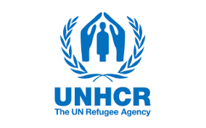
The representative from UNHCR stated that health is a human need and should not be determined by migrant or refugee status. The UNHCR will be working on the specific compact dealing with refugees which will be part of the larger migrant compact being worked on in Mexico. Technical systems, funding, collaboration and support needs to be put in place for host countries to help with the burden of migrants on local health systems. The overburdening of health systems can set back any progress on SDGs within these host countries. The representative from IOM explained that migrants’ health must now be mainstreamed and stressed that migrants need to be allowed to flourish and add to the society within which they now live. He declared that we are a world on the move and it is important for the global world to understand the particular vulnerabilities and needs of these populations. He then explained that health is not always taken into consideration when discussing issues relating to migration. The IOM representative talked about the toxic public perception about refugees/migrants and how they overwhelm infrastructures of countries, but reminded the forum that we shouldn’t forget that immigrants pay taxes.

Climate Change and Mental Health

What role does the mental health community play in discussions on climate change? This was the topic of the December 6 evening event hosted by the NGO Committee on Mental Health. The event included a lovely pre-event appetizer and networking hour followed by a screening of Al Gore’s newly released documentary “An Inconvenient Sequel, Truth to Power.” The screening was followed by a question and answer session with the chair of the NGO Committee on Mental Health, Vivian Pender MD, and UN Department of Information representative Dan Shepard. The film focused on the efforts of Al Gore and other climate change response advocates to push for global action. It highlighted the Paris agreement and the efforts made to ensure the support of all member states in implementing action plans. This included persuading the Indian government to agree to embrace sustainable energy by convincing an American solar power company to provide the supplies needed to begin to build a solar power industry in India.

The film also, of course, addressed the disappointment over the American government backing out of the Paris agreement following the election of Donald Trump. Gore’s message was one of hope and encouragement because a number of American cities are taking their own measures to develop sustainable energy programs and choose to observe the agreements made in Paris, whether the federal government is on board or not. The film was a reminder that we still have a lot of work to do when it comes to climate change, but the global response is changing and there is hope.
The discussion portion of the event brought the focus back to the role that the mental health community plays in addressing climate change. The moderator for the event presented a position statement created by the American Psychiatric Association which was submitted to the UN. It mentioned the numerous ways in which climate change has an impact on an individual’s mental health. Dan Shepard then spoke to the role of the UN in the climate change agenda. Two ways in which the UN is involved are by providing a forum for discussion and by assisting member states with following through with their commitments made in Paris.
The question and answer portion of the event brought up many key themes related to climate change and mental health. Several guests shared their experiences of working with populations impacted by climate change. One example was responding to the needs of those who are being negatively impacted by the push for sustainable energy, such as coal miners in West Virginia in the United States. The guest who had experience working in this area reminded his colleagues that while we cannot halt the necessary shift from fossil to renewable energy, we must consider the losses faced by those whose livelihood, and even to some extent their identity, are closely tied to old industries. A few other key themes that arose were the importance of professional organizations like the APA recognizing the impact of climate change on the individuals served by their profession, as well as turning disasters into opportunities. By taking a devastating event like hurricane Maria in Puerto Rico, and turning it into an opportunity to rebuild safer and more sustainable infrastructure and implement policies that protect the most vulnerable, an opportunity to empower communities is created.
Overall, the event was interesting as well as inspiring and we can’t wait to see what the NGO Committee on Mental Health comes up with next! For more information on the NGO Committee on Mental Health, please visit http://www.ngomentalhealth.org/

UN Celebrates 70 Years of Human Rights!

“All human beings are born free and equal in dignity and rights…stand up for human rights.” This was the message shared by Zeid Ra’ad Al Hussein, the UN High Commissioner for Human Rights during the event leading up to the celebration of the 70th anniversary of the Universal Declaration of Human Rights. During a briefing hosted by the Department of Public Information (DPI) on December 7, 2017, DPI representative Martina Donlon announced the upcoming launch of a year-long #StandUp4HumanRights campaign to promote, raise awareness, and remind states of their responsibility to uphold the basic rights defined by the Universal Declaration of Human Rights (UDHR). The goals of this program are to promote understanding of universal rights, engage civil society, member states, youth, and others in standing up for the rights of all, and speaking out when discrimination is observed. This campaign will take place on a number of social media platforms and calls for participation of individuals all over the world! In addition to the campaign, celebratory events took place on December 10th, 2017 in Paris, and December 11th, 2017 at the UN NY headquarters. For more information and to learn how you can be featured in the #StandUp4HumanRights campaign please visit http://www.standup4humanrights.org/en/index.html
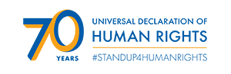

Following Donlon’s announcement, there was a panel discussion which included Hui Lu, a representative from the Office of the High Commissioner for Human Rights and Renzo Pomi, a human rights lawyer with Amnesty International.
Lu presented on the progress made over the last seven decades in the area of human rights. She recalled the numbers of treaties that have been adopted by member states including the convention on the Rights of Persons with Disabilities, and other initiatives such as the UN Free and Equal campaign for LGBT rights. Lu reminded her audience of the important role civil society plays in promoting universal rights by providing assessment of implementation and engaging in the Universal Periodic Reviews.

Pomi talked about universal rights from the perspective of a Human Rights defender and reminded the audience that the enjoyment of these rights is far from universal. As there are several member states who refuse to ratify treaties that would protect universal rights, and there is no enforcing mechanism to hold those who have ratified accountable, there is still a long way to go. Pomi also talked about the struggles that human rights defenders face. Many are considered threats to their governments and are often portrayed as terrorists or criminals. Pomi called for the UN to stand with human rights defenders to hold states accountable for implementing treaties and protecting universal rights.

After each panelist shared their piece, the floor was opened for questions where several representatives from civil society engaged in discussion with the panelists. In the last thirty minutes of the meeting, the audience was invited to record themselves reading one article from the UDHR in their native language as part of the #StandUp4HumanRights campaign. While the event addressed the sobering reality of how far we have to go in order to fully recognize the rights of all people, there was an optimistic energy buzzing throughout the room as people lined up to record their videos.

WORKING GROUP ON GIRLS
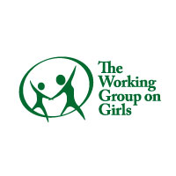
“We are proud members of the Working Group on Girls” is the rallying cry from members of the NGO Committee, Working Group on Girls. Our monthly meeting was lively as always. The Director of the HERSTORY organization gave a presentation about their vision and international work. HERSTORY is a partnership between two agencies, LITWorld and Global GLOW Partnership, both based in California. The five strategies of this organization are to: amplify girls’ voices, create innovative programs inspired by girls’ voices to inspire community driven advocacy, strengthen community based partners, activate allies and to champion girls’ private and public institutions. HERSTORY partners with grassroots and established organizations worldwide that can implement these girl empowerment programs. HERSTORY is in twenty- seven countries, has fifty-two community based partners and serves five thousand girls worldwide. The programs in these communities include weekly meetings to support local girls ages 10-18 with the focus on literacy skills, social empowerment and a yearlong mentorship program. The participants feel supported and most importantly feel a part of something important. Annually, HERSTORY hosts a large summit in New York in conjunction with the International Day of the Girl. HERSTORY participants come to the UN from over ten countries. The Director of HERSTORY has now joined the Working Group on Girls Committee. She is dynamic and is a very welcome addition to the group.
To stay up to date with the NGO WGG, please visit http://girlsrights.org/

Upcoming Events! 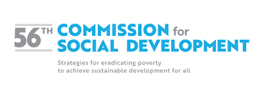
The 56th Commission for Social Development will take place at the United Nations Headquarters in New York from January 29th to February 7th, 2018. The priority theme for this year is “Strategies for Eradicating Poverty to Achieve Sustainable Development for All.” For More information about this event please visit https://www.un.org/development/desa/dspd/united-nations-commission-for-social-development-csocd-social-policy-and-development-division/csocd56.html

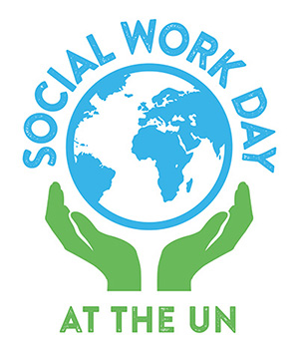
35th Annual Social Work Day at the United Nations

Theme: SDGs, Climate Change and Social Work Practice
The International Federation of Social Workers and the International Association of School of Social Work are pleased to announce that the 35th Annual Social Work Day at the United Nations is scheduled for Monday, March 26, 2018 from 10 a.m. - 12 p.m.
Social Work Day at the UN is a gathering place for people around the world who are working to make a difference. For 35 years students, practitioners, and educators have been convening at the UN to learn more about the UN, innovative projects and issues related to International Social Work and the critical role Social Work plays in the international arena.
Watch for announcements of the opening of registration for the event and for the companion event for social work students that will take place on Sunday, March 25. Please visit https://www.monmouth.edu/school-of-social-work/UN-Day/registration-information.aspx for registration information.

UN Commission on the Status of Women, March 2018 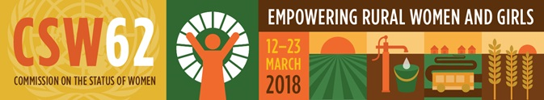

The UN Commission on the Status of Women will meet in UN Headquarters in New York from 12-23 March, 2018. IASSW can register a limited number of additional delegates. If you are interested in registering, contact main representative Lynne Healy by January 10 and she will forward registration instructions (lynne.healy@uconn.edu)

Respectfully,
Justice Konowe
MSW Candidate 2018
IASSW Representative to the United Nations
UCONN School of Social Work
Email: justice.burch@uconn.edu
Shrevie Shepherd
MSW Candidate 2018
IASSW Representative to the United Nations
UCONN School of Social Work
Email: katherine.shepherd@uconn.edu

