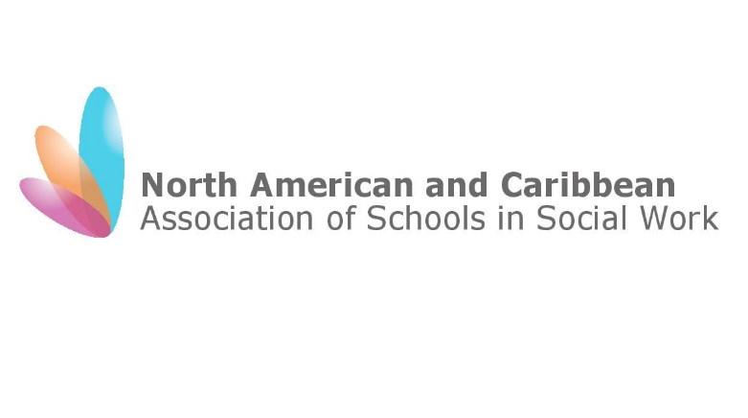
To IASSW Board

From Karene-Anne Nathaniel-DeCaires
President, NACASSW/Vice President ACSWE

Date June 15th 2017

Subject Report to IASSW Board for Dublin meetings Jan-June2018.

In the aftermath of the devastation caused by the powerful hurricanes of 2017, crisis response teams were sent to the most hard-hit countries in the Eastern Caribbean and multiple shipments of supplies were dispatched both of which were coordinated through the regional universities. There has been a discussion among members of the NACASSW executive committee about the need to issue a statement about environment justice that draws attention to the prevailing vulnerabilities of under-developed areas and the severe hardships faced by already vulnerable populations such as older persons and those in poverty. The prejudice and politics of aid was also discussed as a topic for special attention.

The CASWE-ACFTS held its annual conference at the University of Regina, Saskatchewan, Canada in May 2018 under the theme “Honouring Reconciliation and Respecting our Differences.”

The ACSWE (Caribbean) has had a frank discussion among its executive about the seeming declining interest in regional association involvement and the need to revisit the TOR’s (20 years on) to determine future directions. At this time, there is no expression of interest to host the 2019 Caribbean Conference and a decision is pending on the format and focus of a 2019 meeting.

In April, the President was contacted (via email) by a MA student from the University of Luxembourg with regards to a research project focusing on the application of the Global Standards. The interview was held via skype in June and the questions posed addressed the knowledge of the IASSW in this region, the values of SW education in the region, knowledge and application of the global standards, accreditation requirements, and to what extent the global standards impacted SW education in the region. This was interesting in light of the current conversations in the international arena and the work of the education commission in this (almost identical) regard. Her findings could be instructive to IASSW.

There has been no specific activity with NACASSW for this period. Efforts were made to schedule a virtual meeting with members of the executive committee but unfortunately this did not happen. Members of the executive of the Caribbean Association have faced personal and professional challenges in the past year, and in conjunction with the economic crisis facing the sub-region, these have led to the work of the sub-regional and regional associations being deprioritised. The President would welcome the opportunity to discuss with members and the executive the status of NACASSW and the significant challenges facing this association and any ideas would be well appreciated.

