IASSW Archives: Newly Formed Archive Committee
Lynne Healy, Chair
IASSW’s history is well documented in its archive, held at the Social Welfare History Archive at the University of Minnesota Library in Minneapolis, Minnesota, in the United States. Holdings that date back to the founding of the association in 1928 include official minutes, reports, programs, photographs, and correspondence that tell the story of the global organization and its leaders and shed light on developments in social work education throughout the years. The records are accessible to researchers and there is assistance available from a professional archivist.
This year, IASSW established an Archive Committee to ensure continuing attention to preserving organization records and maintaining a robust archive. Among the challenges are that records are generated by numerous volunteers who function without a permanent office. The Committee has written procedures to help volunteer leaders archive their records. The switch to electronic communication poses special challenges as email exchanges are less likely to be kept and organized than letters on paper. The correspondence files in the existing archive yield particularly rich material for research. The Committee will address this with new procedures but must ultimately rely on the cooperation of the volunteer leaders who run our programs.
Commemoration of the 90th anniversary of the founding of the IASSW at this year’s global conference was greatly enhanced by materials from the Archive. The booth at the Dublin conference in July featured a slide show and several posters on IASSW history, enlivened with historical photos from the IASSW archive (see photos below). Visit the IASSW website (www.iassw-aiets.org ) to see the slide show or click here: https://www.youtube.com/watch?v=EAwup5j7oEI&t=5s. The brief summary attached to this report features several of the photos and captures highlights from the association’s history. Details on each of these developments and more can be found in the archive.
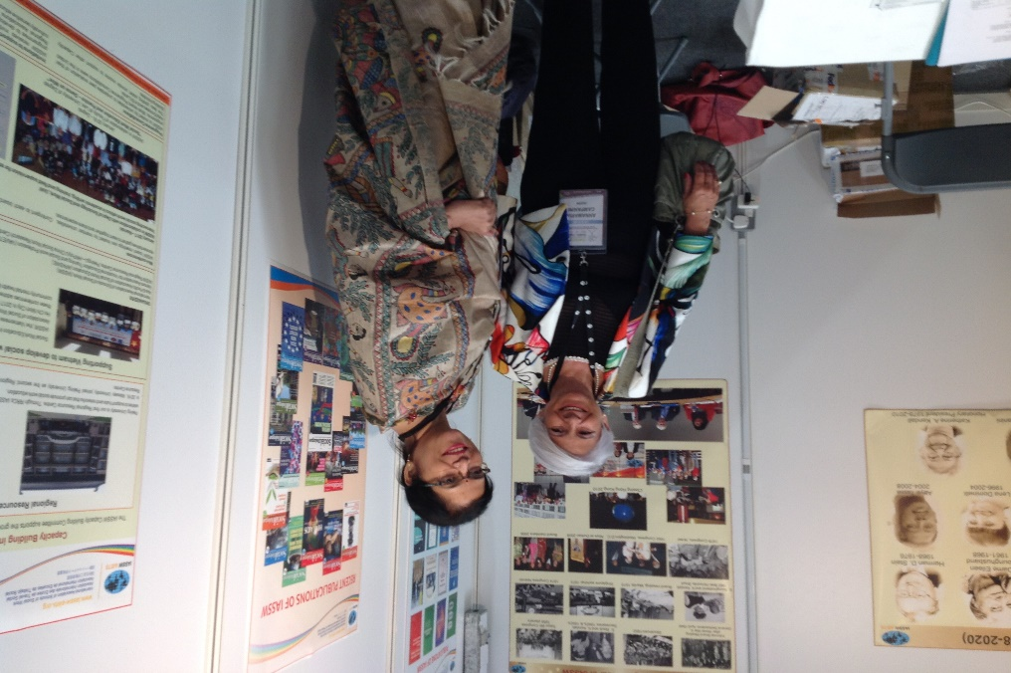
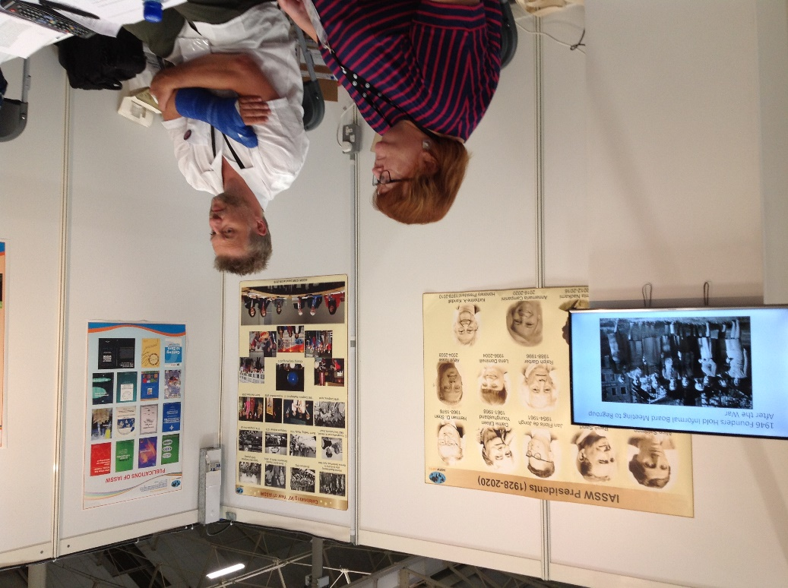
As an IASSW participant, you may be able to help us to enhance our archive. If you have materials or photographs from IASSW events, please contact Lynne Healy, Chair of the Archive Committee (lynne.healy@uconn.edu ) or get in touch with the archive directly.
To contact the Archive:
The current archivist is Linnea Anderson ande3748@umn.edu
IASSW Archive
Social Welfare History Archive
320 Elmer L. Andersen Library
University of Minnesota
222 21st St. S.
Minneapolis, MN 55455 USA Website: www.lib.umn.edu/swha swharef@umn.edu

