NGO COMMITTEE FOR SOCIAL DEVELOPMENT

GRASSROOTS PROJECT: Call for Videos & Comments

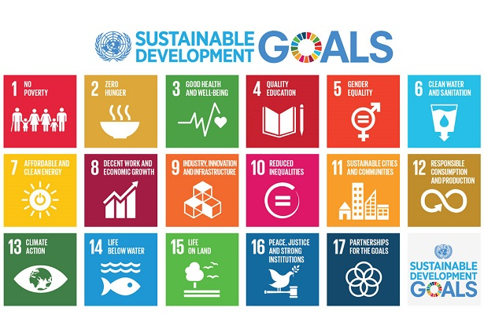
Introduction
In September 2023, governments will meet at the United Nations to assess progress on the Sustainable Development Goals (SDGs). These are a set of big commitments to end poverty and hunger, ensure access to education, health, water and sanitation, and achieve equality including gender equality. The plan also includes goals to take care of the land, the oceans and our climate by 2030. The UN Secretary General calls it a “rescue plan for people and the planet.” 2023 marks the halfway point in this 15-year agenda.
We are inviting people from around the world to share their experiences. We especially invite short video statements (2 minutes). We will use these to bring your voice to the officials at the United Nations.

Video Content Suggestions:
First, briefly introduce yourself and your location. You do not have to use your whole name but a first name is helpful. State your location in general terms (example: My name is Maria and I am in a village in a rural part of Southern Mozambique).
Then, respond to the following:
If you could deliver a message to this SDG Summit in September 2023, what would your message be? Please share in a few sentences what you would most want government and United Nations officials to hear. You might include your hopes for 2030 and what is most needed in your area to improve the quality of life.

Please see the guidelines for preparing your video to be sure it is of good quality.
When the video is complete, please send it by email to csocdsurvey@gmail.com no later than 17th July, together with the enclosed consent form to allow us to use your video.

GUIDELINES FOR VIDEOS
Instructions for Introducing Yourself on a Videos:
Briefly introduce yourself. You do not have to use your whole name but a first name is helpful.
State your location in general terms (example: My name is Maria and I am in a village in a rural part of Southern Mozambique).
For a Good Quality Video:

Before you shoot your video, be sure to review the guidelines below.

Lighting: Make sure there is enough light on your face. If you are inside, you could face a window or a lamp. If you are outside, you should be looking in the direction of the sun. Cloudy days are often the best for recording.

Background: Remember that many people around the world will be seeing this video, so you should be comfortable with lots of people seeing what is behind you while you are recording.

Background Noise: Please make sure that you can be heard and that as much as possible there is no background noise, or it is not too loud that you cannot be heard.

Recording: Ask the person recording you to hold the phone or camera as still as possible. You can be sitting or standing, but make sure the video captures some space above your head down to your shoulders.
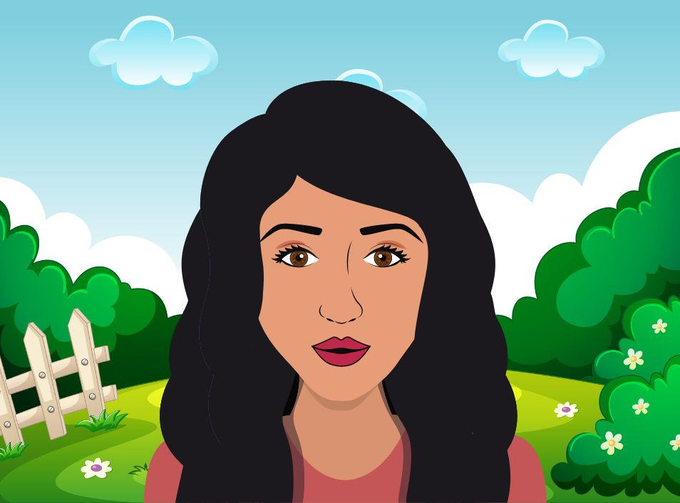

Using a Smartphone:
- Record with the phone held horizontally, so that the video is wide, not tall.
- Use the front-facing camera (the one you would use to take pictures of other people, not selfies).

- If you don't have a front-facing camera on your phone, have a friend or family member to record you, place your phone on a shelf, desk or some books.

Afterwards: Watch your video and review each of the guidelines above. Make sure you can see and hear yourself well! Your voice should sound clear and easy to understand. Make sure there is no or minimum background noise. You should be able to see your face without any shadows.

Translation: If your video is in another language other than English, Spanish, French or Portuguese, we ask to please provide the English translation of what is being said in the video. If possible, we would also ask that you provide a text/transcript of what you said. This will make it easier for our translators.

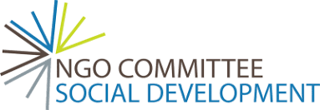

MEDIA AND COMMUNICATIONS CONSENT FORM
The NGO Committee for Social Development (“NGO CSocD”) and others working for and on their behalf and each of its respective licensees, successors and assigns, may wish to publish photographs (image) for use in print, video and online marketing materials, in addition to other publications and educational materials. These materials may include information about people, projects and events designed to share the work of NGO CSocD and provide information to supporters. Promotional materials include, but are not limited to, newsletters, magazines, brochures, as well as digital media including websites and social media.
Return this form with your video to csocdsurvey@gmail.com
You can withdraw this consent at any time in the future by contacting the officers of NGO CSocD at ngosocialdevelopment@gmail.com

PHOTOGRAPHIC / VIDEO / AUDIO / COMMUNICATION RELEASE
CONSENT AUTHORISATION
I authorise the NGO Committee for Social Development (“NGO CSocD”) and others working on their behalf and each of its respective licensees, successors and assigns to take and use photographs, videos, sound recordings and any reproductions or adaptations of myself (‘the material’), in full, in part, or in conjunction with any words or drawings, in any company publication, production or presentation.
I acknowledge that I do not have any commercial rights in any NGO CSocD production or presentation that includes the material. I understand that this material will not be provided to any third party outside of those detailed in this document.
Full name: ___________________________________________________________________
Signature: ___________________________________________________________________
Street address: _______________________________________________________________
Country: _______________________________ Telephone: ________________________
Email: _______________________________________________________
DATE: _____ / _____ / 20_____

OPTION FOR RESPONDING IN WRITING
If you prefer, you can instead share your thoughts in words or respond both with a video and your thoughts on this form. If responding in words, please use the form with questions below.
About You:
Name (optional)___________________________________________________________
Country: ________________________ State/Province/Region ____________________
Are you in a city ___, town ____, or rural area ___? Very briefly, describe your area.

Are you a youth (18-25) ____, adult_____, elder____ (over 60)
Briefly, what type of work do you do?

The questions:
- Since 2015, how have conditions for living improved, worsened or have they stayed about the same in your area?

- What is most needed in your area to improve the quality of life?

- Tell us about a current program that is having the most success in working to achieve one or more of the Sustainable Development Goals for 2030?

- If you could deliver a message to this SDG Summit in September 2023, what would your message be? Please share in 2 or 3 sentences what you would most want government and UN officials to hear. You might include your hopes for 2030.

Please return your comments to: csocdsurvey@gmail.com

