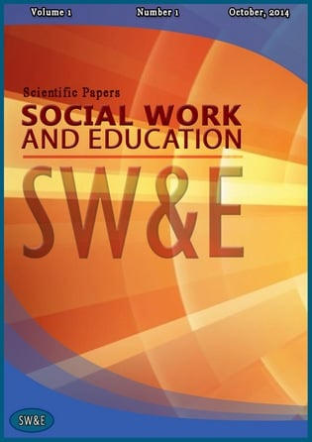
CALL FOR PAPERS
Journal: SOCIAL WORK AND EDUCATION
ISSN 2520-6451 e-ISSN 2520-6230
Special Issue: SOCIAL SERVICES IN CRISIS:
THE EXPERIENCE OF UKRAINE AND EU

We cordially invite researchers and practitioners to submit manuscripts for consideration in the Special Issue "SOCIAL SERVICES IN CRISIS: THE EXPERIENCE OF UKRAINE AND EU" of the journal SOCIAL WORK AND EDUCATION.
Theme and Scope
The Special Issue aims to delve into the peculiarities of social services provision in the context of crisis, focusing on the experiences and approaches taken in Ukraine and the European Union. We encourage original contributions addressed to central questions such as:
- the re-scaling of social services on the local and community level;
- the place and space of an “institutionalisation’ and “(de) institutionalisation” in the fields of social services providing and social work;
- the place and space of personalized social services in support of individual people or families to safeguard their fundamental rights and facilitate their social inclusion;
- case reports of successful social work interventions for social services providing for individuals and families in crisis.
The special issue will also focus on post-war reconstruction, in which social work plays an important role.
We welcome original research articles, reviews, case studies, and theoretical papers that shed light on the challenges, innovations, and best practices in the field of social services during times of crisis.
Submission Deadline: September 1, 2023
About the journal:
SOCIAL WORK AND EDUCATION is a quarterly international academic open-access journal published by the Ternopil Volodymyr Hnatyuk National Pedagogical University and the NGO "Center for Social Development and Innovation," Ukraine. Indexed in Google Scholar, Index Copernicus, Site Factor, Open Journal Systems, Journal Factor, DOAJ, CrossRef, World Cat, OAJI, and others, the journal maintains a strong commitment to advancing knowledge in social work and educational sciences. Recognized by the Ministry of Science and Education of Ukraine, it is categorized under "B" in the List of scientific professional editions of Ukraine for branches of science: 231 – Social work, 011 – Educational and pedagogical sciences.
Manuscript Requirements:
- Include a cover page with the following information:
  - Name(s) and surname(s) of each author (in English and Ukrainian). For authors needing Ukrainian translations, the Editorial Board provides support upon request.
  - Affiliation of each author (in English and Ukrainian)
  - Degree of each author (in English and Ukrainian)
  - E-mail(s)
  - ORCID number (ORCID can be obtained at https://orcid.org/)

- Structure the manuscript in the following way:
- Title of the article (in English and Ukrainian)
- Abstract (in English and Ukrainian, 1800 characters) and keywords
- Introduction
- Aim and purpose of the work/research
- Research methodology (for research papers)
- Results (Divide the text into meaningful sections with concise subtitles in bold letters)
- Discussion
- Research limitations (for research papers)
- Conclusions
- References

- Requirements for text design:
- Page format - A4
- Font - Times New Roman 12
- The interval - 1.5
- Paragraph indentation - 10 mm.
- Margins: left - 20 mm, right - 20 mm, top - 20 mm, bottom - 20 mm.
- Volume - from 8 to 12 pages.
- Article language: Ukrainian, English.
- Use APA-7 for In-text Citation and References:
- Please follow the АРА style for in-text citations and references
- Cite sources by placing parentheses with the author's last name and publishing year in the text.
- For more precise quotes or citations, include page numbers.
- Secondary sources should be cited with the original author's name followed by "cited in" and the secondary source's author's name.
Guidelines for Submissions:
Submit your manuscript via the link: https://journals.uran.ua/swe/about/submissions or email it to annaslozanska@gmail.com.
The Editorial Board reserves the right not to consider articles that do not meet design and scientific style requirements, lack scientific novelty and practical significance, or deviate from the theme of the journal. Articles submitted using automatic computer translators or containing grammatical and stylistic errors will not be considered.
Each submission will be checked for plagiarism. The journal prioritizes the ethics of scientific research, and articles found to contain plagiarism will be rejected.
Each submission undergo double-blind peer review. Authors may receive feedback and be asked to revise their articles after the review process.
We look forward to receiving your valuable contributions and sharing insights on the vital topic of social services in crisis.
No fees are charged for processing and publishing a high-quality manuscript in English.
Sincerely,
Dr.Hanna Slozanska, Editor-in-Chief (annaslozanska@gmail.com)

