International Association of Schools of Social Work
President Report (January to June 2017)

Dear Colleagues,
I am pleased to present my second President report for the period of January-June, 2017. During these months I continued to communicate with Chairs of committees, Presidents of Regional Associations, and with Rashmi through Skype, WhatsApp and emails. We are using technology with minimum cost for the IASSW work.
As discussed and approved by the Board in Nairobi Board Meeting IASSW will have 3 meetings in 2 years. There will be NO board meeting in June/July 2017. You all must have received messages from Rashmi that we will be preparing the reports and Board will accept and approve those reports electronically/via emails.
The last six months was marked by several significant activities of IASSW. I would like to highlight the following:

Nairobi Board Meeting &Capacity Building Conference

The new year have started with our Nairobi Board meeting. It was hosted by IASSW Vice President and ASSWA President Gidraph Wairire along with his colleagues in University of Nairobi on January 11-12, 2017. Meeting was very much productive and Board took some important decisions to enhance the activities and the development of IASW. Minutes were circulated on January 31, 2017.

On January 13 we have had the opportunity to participate and contribute to the organization of a very interesting Regional Seminar at the newly build conference center of the University. Topic of the seminar was 'Intersecting social work ethics in academic writing, training and field supervision for ethical social work practice'
As a side event, we could have a remarkable exchange with the KENYA HUMAN RIGHTS COMMISSION an umbrella association that is working on defense of human rights.

IASSW Board is very much thankful to Gidraph Wairire and University of Nairobi for hosting us.
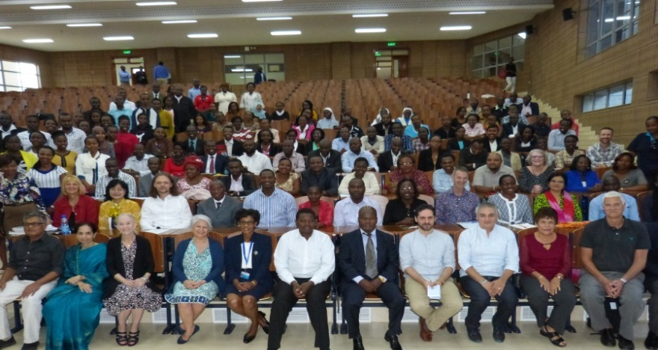
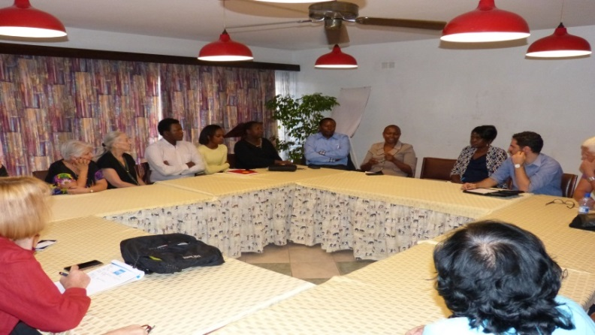
Figure 1: IASSW Board of Directors, Faculty and students from University of Nairobi and other participants of conference
Figure 2: IASSW Board of Directors with colleagues from Kenya Human Rights Commission

Pictures were posted on IASSW website, Facebook and Twitter and I hope that you must have seen those.

World Social Work Day
The 2017 world Social work day was celebrated in different part of the world with many initiatives focusing on the third pillar of the Global Agenda: Working toward environmental and community sustainability.
Social Work day in Geneva- IASSW and IFSW in collaboration with United Nations agencies, the University of Applied Sciences and Arts Western Switzerland – Social Work, Geneva (HETS) and UN Research Institute for Social Development (UNIRISD) have organized the “Social Work and Sustainability” conference with the participation of many representatives of UN agencies, academics and NGOS. This was held on March 21 and 22, 2017 at the prestigious Palais des Nations, Geneva.
Annette Lavanchy and Nicoline IASSW representatives in Geneva were the organizers, together with IFSW representatives, of the two days 21st and 22nd March at UN. This initiative was very successful with a lot of participants. The UN representatives in the round table expressed their interest in cooperating with our International Association. Nino Zganec made a very interesting introduction to the second day and Lena Dominelli a brilliant and thoughtful key note speech.
The key note address was presented by Lena Dominelli (Durham University, UK and former IASSW President). Reflecting on “Green social work, environmental justice and the global agenda”, Lena Dominelli emphasized the human impact of climate change and environmental disasters and the roles that social work needs to play in prevention, mitigation and sustainable development.

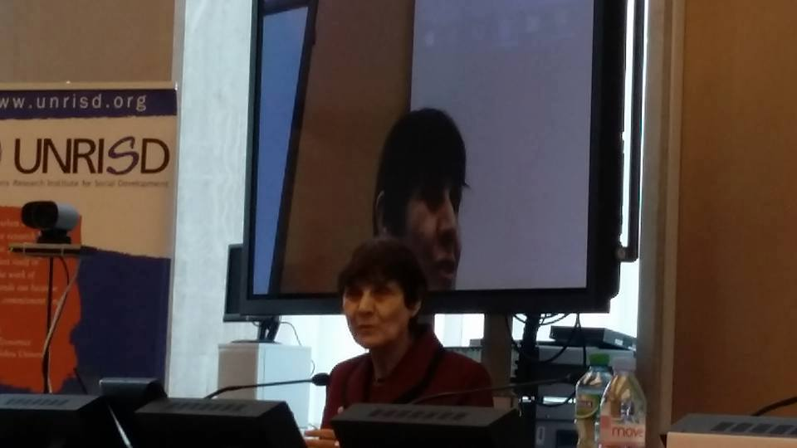
Figure 4: Nino Zganec gave opening remark
Figure 3: Lena Dominelli gave presentation on Green Social Work

The conclusions were prepared by combined efforts from Rory Truell, Anne Lavanchy and myself underlined some commitments and possible cooperation between IASSW, IFSW and UN Agencies:
- Increasing the knowledge and visibility of social work approaches and capacity within UN Agencies (eg. form a body / network of social workers working with and within the UN agencies)
- Creating joint guidelines on how social work organizations can successfully engage with UN national and regional offices.
- Building into social work education and practice related policies information on the role of UN agencies, the SDG’s and bridging this with social work approaches to development.
- Establishing joint strategic research that enhances the role of social work in fulfilling the SDGs.
- Providing information on the role of social work in fulfilling the SDGs and creating job descriptions to support joint workforce development strategies

At the end of the 21st meeting there has been a launch of the book Getting to Zero. Global Social Work respond to HIV, chief edited by Mark Henrikson. This joint initiative IASSW/UNAIDS was undertaken by Vimla Nadkarni (Immediate Past President of IASSW) and Mark Henrikson after the WSWD in 2014. The book can be download for free at : http://www.unaids.org/en/resources/documents/2017/global-social-work-responds-to-HIV

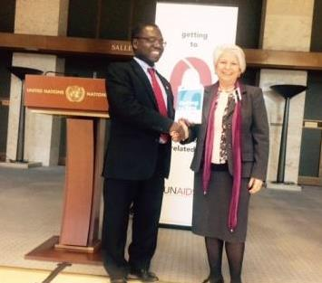

Figure 5: L-R: David Chipanta ¦ Senior Advisor, Social Protection ,Joint United Nations Program on AIDS (UNAIDS and Prof. Annamaria Campanini, President IASSW at the of Launch of Getting to Zero: Global Social Global Social Work Responds to HIV on March 21, on WSWD at Geneva
Social Work Day at the UN Headquarters - New York
34th World Social Work Day was celebrated on April 4, 2017 at the UN Headquarters New York, which focused on “Promoting Community and Environmental Sustainability”. The presentations underlined different experiences and reflections on the topic, from a variety of positions: the Bangladesh Ambassador Masud Bin Momen, Permanent UN Representative of the Mission of Bangladesh; John Ennis, Chief of Information and Outreach in the Office of Disarmament Affairs-UN; Terri Klemm, Associate Professor and BSW Program Director, Centenary University; Elizabeth Gustafson MSW Student from the University of Connecticut, Roberto Borrero, NGO Committee on the Rights of Indigenous People. Shirley Gatenio Gabel (IASSW) served as co-chair of the event with Robin Mama (IFSW).
As IASSW President, I had the task to wrap up the discussion and providing concluding remarks.
The WSWD was attended by almost 400 people: professionals, students, teachers and the event was video recorded by the UN. http://bit.ly/2t63cjs
This celebration was followed by the Student Forum’s on “World Water Rights: Promoting Environmental Justice in a Globalized World”.
These initiatives are very important to strengthen the link and the cooperation with UN, but also to make visible the social work commitment in the society. The celebration of the WSWD is an important occasion to strengthen or to establish new contacts, cooperation and partnership with UN organizations and with allied international NGOs; to spread knowledge about social work, its values, principles and methods in practice and theory among UN-organizations and allied international NGOs; to highlight social work actions, policies and achievements in the pursuit of common goals and to disseminate the knowledge about UN activities, goals, program and campaigns among social workers and social work organizations and schools.
We are looking forward to receiving documents about initiatives that have been undertaken in different countries so that regional observatories can prepare a comprehensive report about the engagement of social work in promoting environmental and community sustainability.
We are working hard to have future World Social Work Day celebrations also in UN Bangkok and Nairobi headquarters. We hope to have more representatives globally and make it truly international.

1. Different Meetings in Paris
- 24 th January Meeting with UNAFORIS
The European Association had its biennial conference in June 27-30,2017 and they organized a planning meeting in January.
I was invited to participate and to present the IASSW to the President and the Secretary of UNAFORIS ( the organization who collect the French schools of social work). It has been an important opportunity to discuss about our mission and to describe our organization and our activities. The meeting has been very interesting and productive. There is a will to increase the participation of the French schools to IASSW. I collected also some availability to translate documents of our website from English to French.
-24th January Meeting with the UNESCO representative
I’ve presented the situation of the classification and asked if he can inform us on how the classification has been defined, through which kind of consultation and which kind of strategies we can use to bring some changes and to classify social work in the social sciences. At the moment we have been informed that the Unesco Statistic Institute is the responsible for this classification.
- 25th January Meeting organized by the International Campus for an ecologic civilization (Le Campus International pour une Civilisation Écologique : www.groupe-bremond.com). This is an interesting project that aims to realize different initiatives to develop a different vision on the ecological matter, not only as technical one, but as strictly connected with the community sustainability and development. I represented IASSW in this process (that involves also the China Europe Forum) and I created links with the UNAFORIS that can be more directly involved as our future member in the activities of this group, related to community and environmental sustainability.

2- February London meetings
Owners meeting with Sage
International social work journal is doing very well. There is a need to clarify some roles and to redefine the Editorial Board and the list of reviewers.
Lena Dominelli has resigned some months before of her term from the role of Editor that she did very well during these years, improving a lot the quality and the inclusiveness of the journal.
Meeting with Ruth Stark and Rory Truell
This was also the occasion to meet with IFSW President and Secretary to discuss the relationship between the two organisations and find a good way to continue our cooperation in the future.

3- March Dublin meeting
The focus of this tripartite meeting, which I attended with Nino Zganec, was on different topics. The International Journal decision for the future, the Tripartite agreement after 2020, the decision about the next 2020 conference and the meeting with the local committee of the 2018 conference in Dublin.
Concerning the ISW Journal it will be a call for future editor/co-editor, new editorial board with 2 representatives for each organisations and a revision of the reviewer list.
We decided to go on with the cooperation between the three organizations both for creating the Global Agenda after 2020 and to continue to have joint conferences. David Jones was confirmed as coordinator of the Tripartite for the Global Agenda activities.
Concerning the location for 2020 conference the decision was postponed after June. Two EOI were considered: Calgary, Canada and Rimini, Italy. Calgary didn't have the first two requirements (one local representative for each international organisation and a letter of agreements between them). For these reasons as ICSW and IASSW President thought that only Rimini fulfilled the conditions and that rules of the bid cannot be changed during the process, but IF, in the interest of holding conferences in different regions, supported that a conference be held in North America and request more time to have a consultation with their executive board members. A decision to add in the bid a rotation between regions will be added for the future.
The preparation of the 2018 conference is going well and local committee is very committed and enthusiastic.

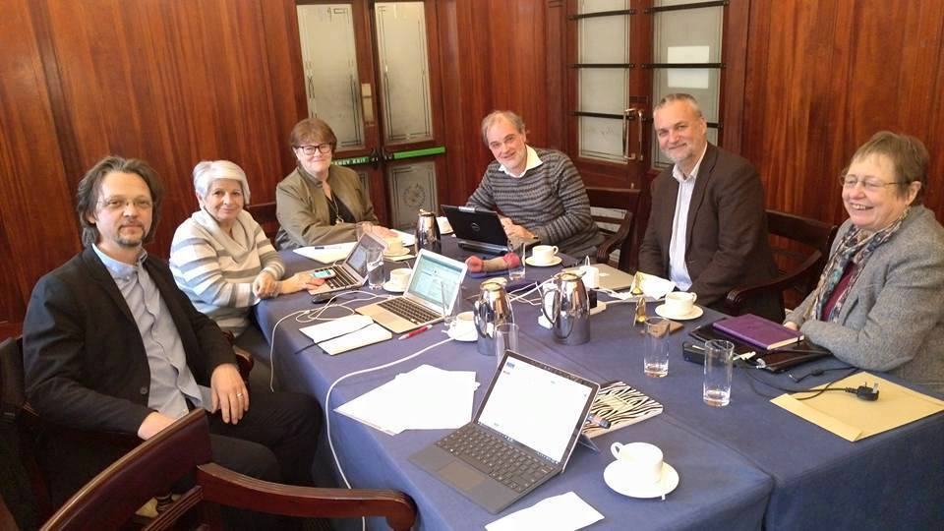

Figure 6: L-R: Nino Zganec , Annamaria Campanini, Eva Holmberg-Herrstom, David Jones, Rory Truell, Ruth Stark

My participation in Conferences/ Workshops
TORINO- 10 March
The Torino University has organized a conference on March 10 on Social Workers as actors of social policies and they have invited me as a keynote speaker (International community as political actor) together with John Gal and Idith Weiss-Gal (Social Workers as political actors). At Turin University in a very interesting conference on social work policy engagement. Under the coordination of Manuela Naldini, Annamaria Campanini presented a speech on International community commitment. Idith Weiss and John Gal on policy practice, Italian scholars (Tousejin and Cappellato) discussed a research on professionalism .The conclusion were drawn by Marilena Dellavalle
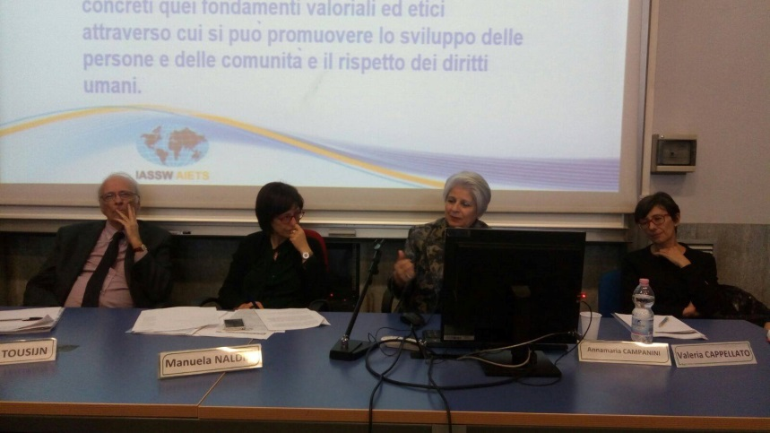

BRISTOL 14 March
A celebration of the WSWD organized by the University of West England and different social services organisations. A presentation of International dimension of Social Work and role of IASSW, in relation also to the Global Agenda was very well accepted by the participants.
ROMA 17 March
A celebration of the WSWD with ASSNAS, the first association of Social Work in Italy.
PARMA 25 March
Meeting with CIF Italia that would launch a cooperation project with IASSW to enhance the exchanges of MA students .
International day at Connecticut University 11 April
Every year the Connecticut University is celebrating the International Day of Social Work and I’ve been invited to give a speech about the migration in Europe with a focus on Italy and the role of social workers facing this problem. The participants were interested and made a lot of questions. Students have also prepared posters related to situations of different countries that they have analysed focusing on human rights and social justice.
Meeting with two IFSW representatives at UN and visit to Manmouth University- 14 April
Prof. Robin Mama and Michael Cronin have invited me to visit Manmouth University and meet colleagues and students to speak about international social work and the role of IASSW.
It has been also an important occasion to discuss the cooperation between IASSW and IFSW that they represent at UN New York.
Aalborg 19-22 April- ESWRA conference
The European association of social work research organaised the 7th conference. I was invited to give a welcome speech to the participants. This has been an occasion to present the IASSW statement on research and to underline the role of IASSW and its activities.
University of Gävle- 7-9 June
I have been invited by Department of Social Work and Psychology University of Gävle. During this visit I gave presentation on Roles and Activities of IASSW, had brief meeting with some students from International Social Work programme on Inter-University Collaboration in Social Work Education.
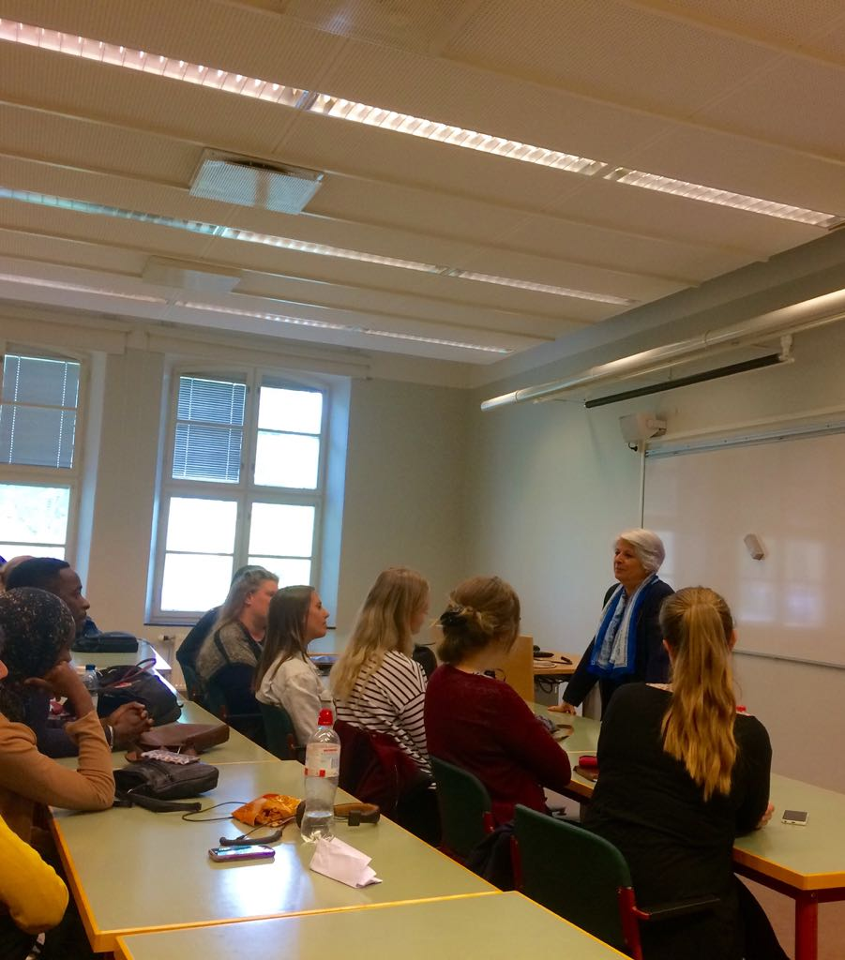

J

PARIS EASSW - UNAFORIS 2017 European Conference- 26/29J une
EASSW - UNAFORIS 2017 European Conference was a successful event with 1200 participants from 40 countries. The participants came not only from Europe but also from Africa, Asia, North America and Australia.. President Annamaria represented IASSW during the conference.
EASSW mentioned on their Facebook past as “Powerful message from Annamaria Campanini, President of IASSW: Social work needs a change of mindset, to connect with local communities and to work together to create a sustainable future”.

It was an important occasion to reinforce the connection with the Association of French Schools (UNAFORIS) and enhance the participation and membership of this area to IASSW.

As IASSW president I organized and chaired a preconference on Dialogue on Social Work Education in China and Europe with the participation of p Professors Xinping Guan, Songguo Yi, Jan Yip. You can download the power points on the IASSW website.
ROME, 30 Jume
Seminar at the Italian National Council of Social Workers with two colleagues Mary Ann Forgey from Fordham University and Karen Green Hurdle from Australia, on social work in the Military Army.
MONTREAL- AIFRIS Conference 3/7 July
As IASSW President Iwas invited by Association Internationale pour la Formation, la Recherche et l'Intervention Sociale (AIFRIS) to participate at the conference in UQAM Montreal on “Solidarités en questions et en acts: quelle récompositions” and speak in the
Forum on social work education from the IASSW perspective.
This francophone conference collects people from different countries: France, Switzerland, Belgium, Portugal, Canada, North Africa, Brasil. The topic was very interested and the discussion was focused on Solidarities. A good occasion of exchanges and strengthening links with francophone schools in the world, to meet the new president of the Canadian Association of Schools of Social Work and also to discuss with some north African members the possibilities to improve their participation in IASSW Africa Region.

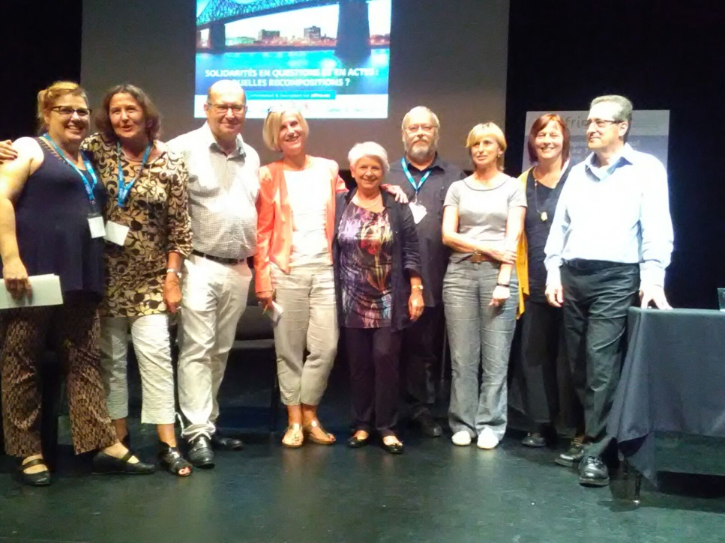

Skype Meetings
- Office bearer’s Skype
On April 26 and June 16 we had Office bearer Skype meeting. We had discussion about activities, progress and difficulties etc.

- Skype with Chair of Committees
President with the help of Rashmi Pandey, Executive Officer tried to have Skype meetings with Chair of each committee respectively. During the Skype meetings progress & development, difficulties & crisis etc. were discussed. Minutes of each Skype meetings has been prepared by Rashmi and shared with the Chair and President. (If you would like to read minutes, let us know).

Updates from IASSW Committees: Each committee have presented their progress reports in January Board Meeting. They will be submitting their reports in July first week and those will be circulated soon.

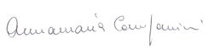
With best wishes,

Prof. Annamaria Campanini
President, International Association of Schools of Social Work (IASSW)

