Babcock University
Department of Social Work and Human Services
Report of World Social Work Day Activities
March 19, 2019
At Babcock University in Nigeria, the World Social Work day was celebrated with colorful activities that kicked off with a presentation at a general staff meeting. The presentation was about the plectra of services provided by Social Workers to Students with special needs at the University.
The celebration coincided with the visit of two faculty from the University of Hertfordshire, Prof. Brian Littlechild and Mrs. Lynette Lee- Messenger. The visit is part of the faculty mobility exchange project funded by the Erasmus plus grant from the European Economic National Agency.
Social Work students, faculty, practitioners along with the guests did an awareness march around the campus promoting Social Work profession and education. The Head of Department, Dr. Jane Adebusuyi along with the coordinator of International collaborations Dr. Augusta Olaore facilitated engagement sessions that promoted the value of Human Relationships in the context of maneuvering conflicts between personal values and social work values in service delivery.
The celebration was concluded with a Seminar on “Maneuvering conflicts between Personal and Social Work values within the context of Spirituality and Child Welfare” with the second year social work students.

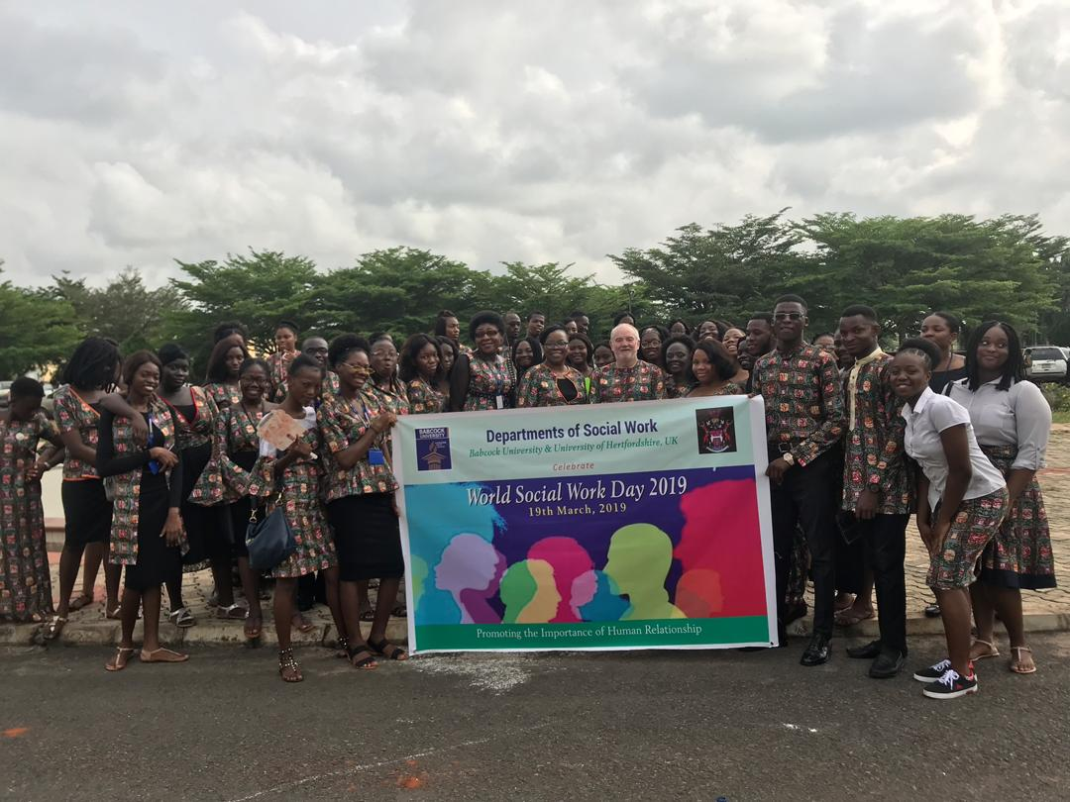
Babcock University Social Work Students with Dr. Jane Adebusuyi, Dr. Augusta Olaore, Prof. Brian Littlechild, Mrs. Lynette Lee-Messanger during the awareness march.
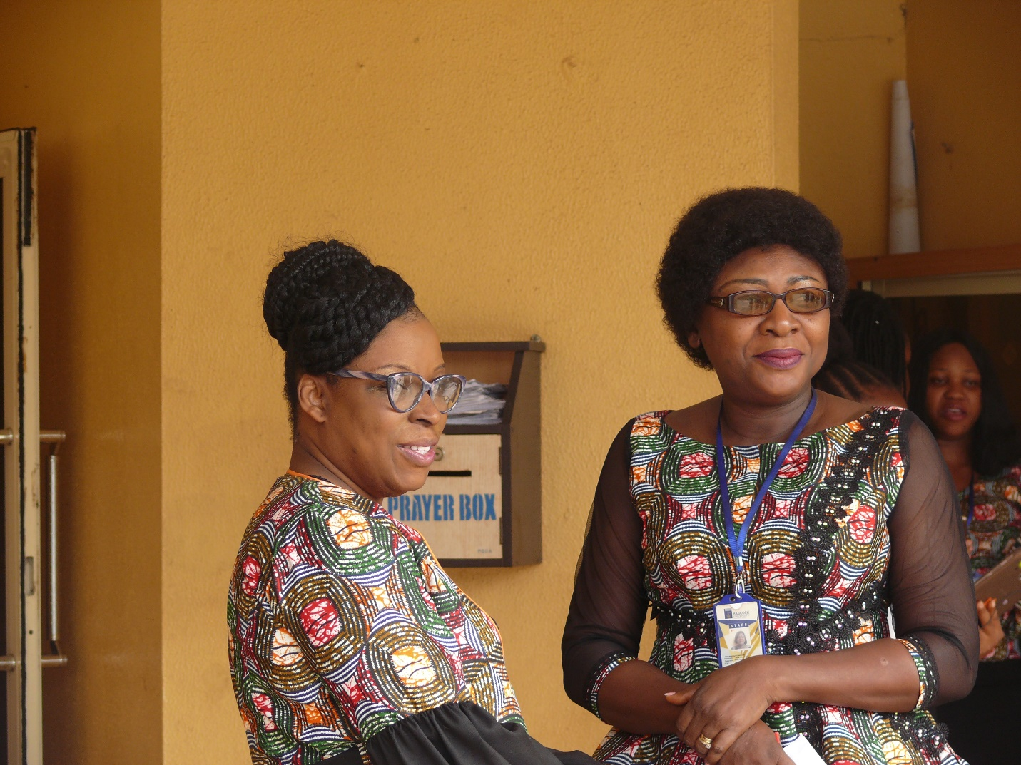 Dr. Augusta Olaore and Dr. Jane Adebusuyi

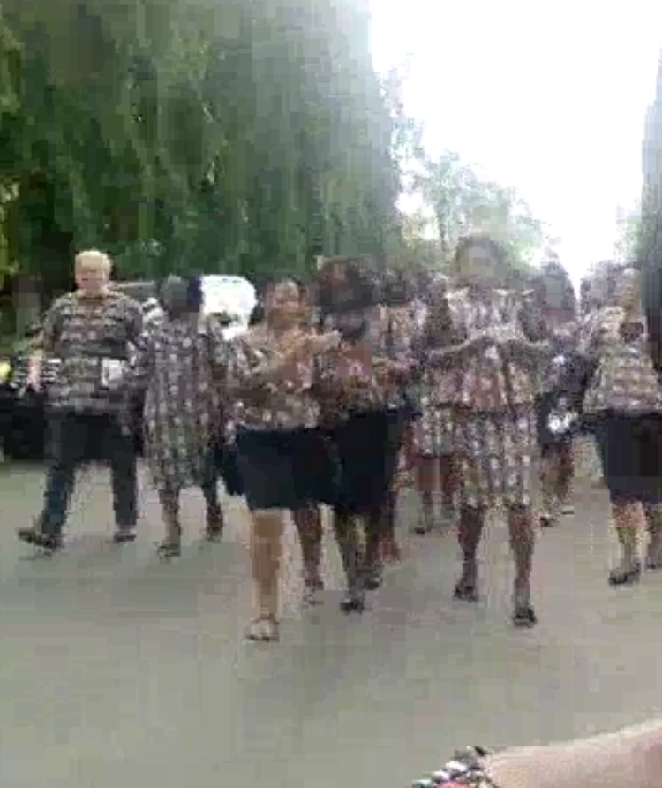 Awareness march
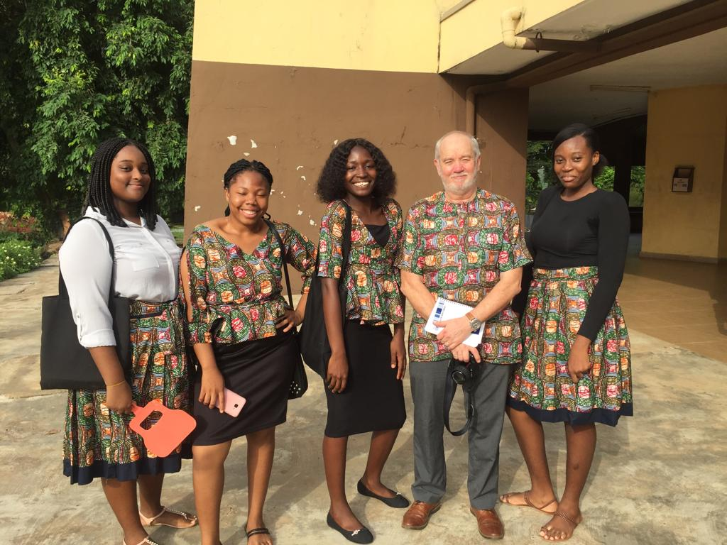
Brian Littlechild with some students
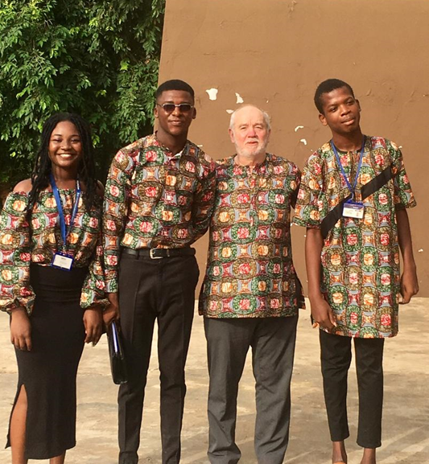 Brian with more students
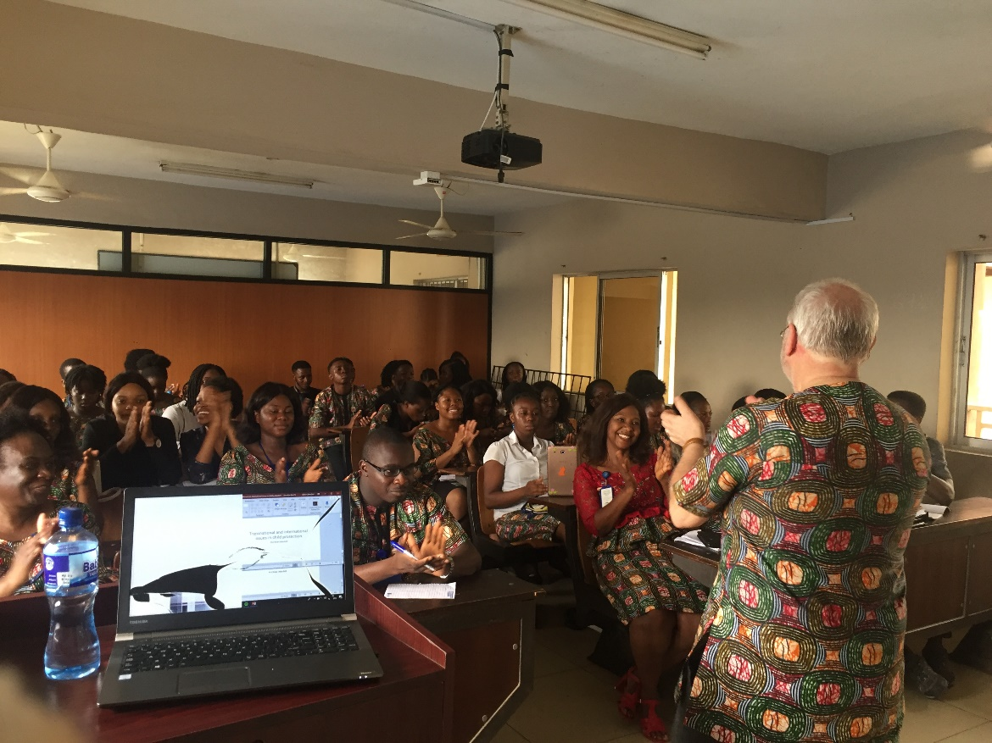
Maneuvering conflicts between Personal and Social Work values within the context of Spirituality and Child Welfare” Seminar
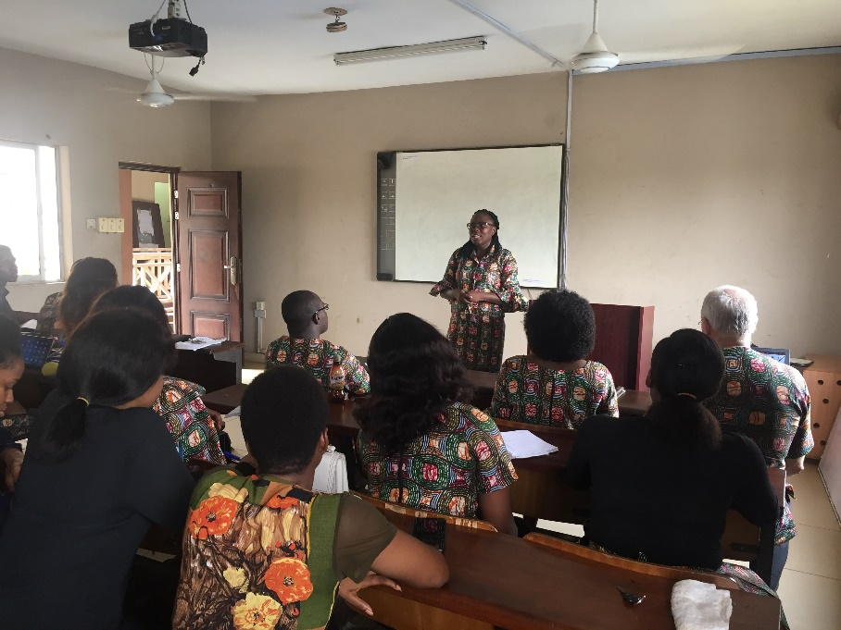 Bose Makinde @ the seminar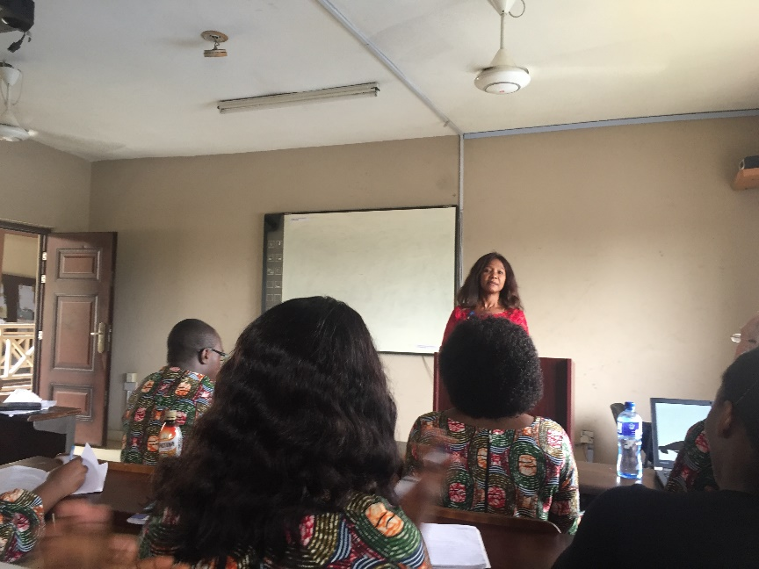 Dr. Rita Ezeokoli @ the Seminar

